Subject:AZCC-MAJOR-OCT-NIRANJAN CHAVAN

Name:Niranjan Chavan email:chavanniranjan8@gmail.com Phone:9822165708

Resource Group

Step1:Creating Resource Group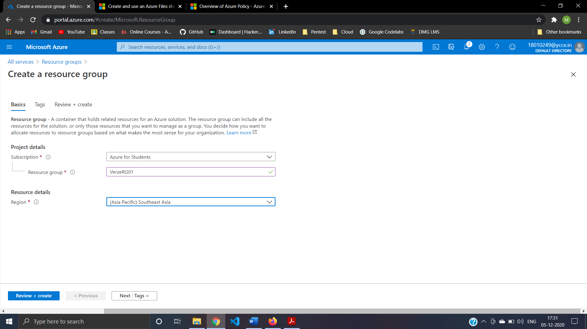

Step2:Create And Review Resource Group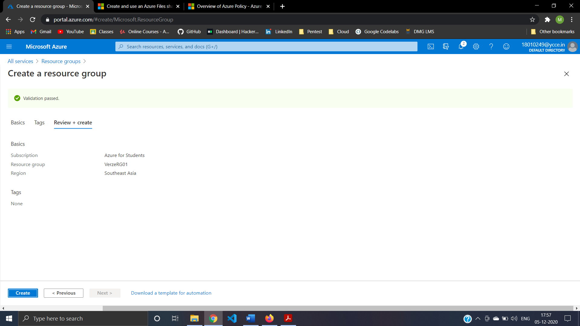

Step3:Creating Virtual Network(verzvnet01) 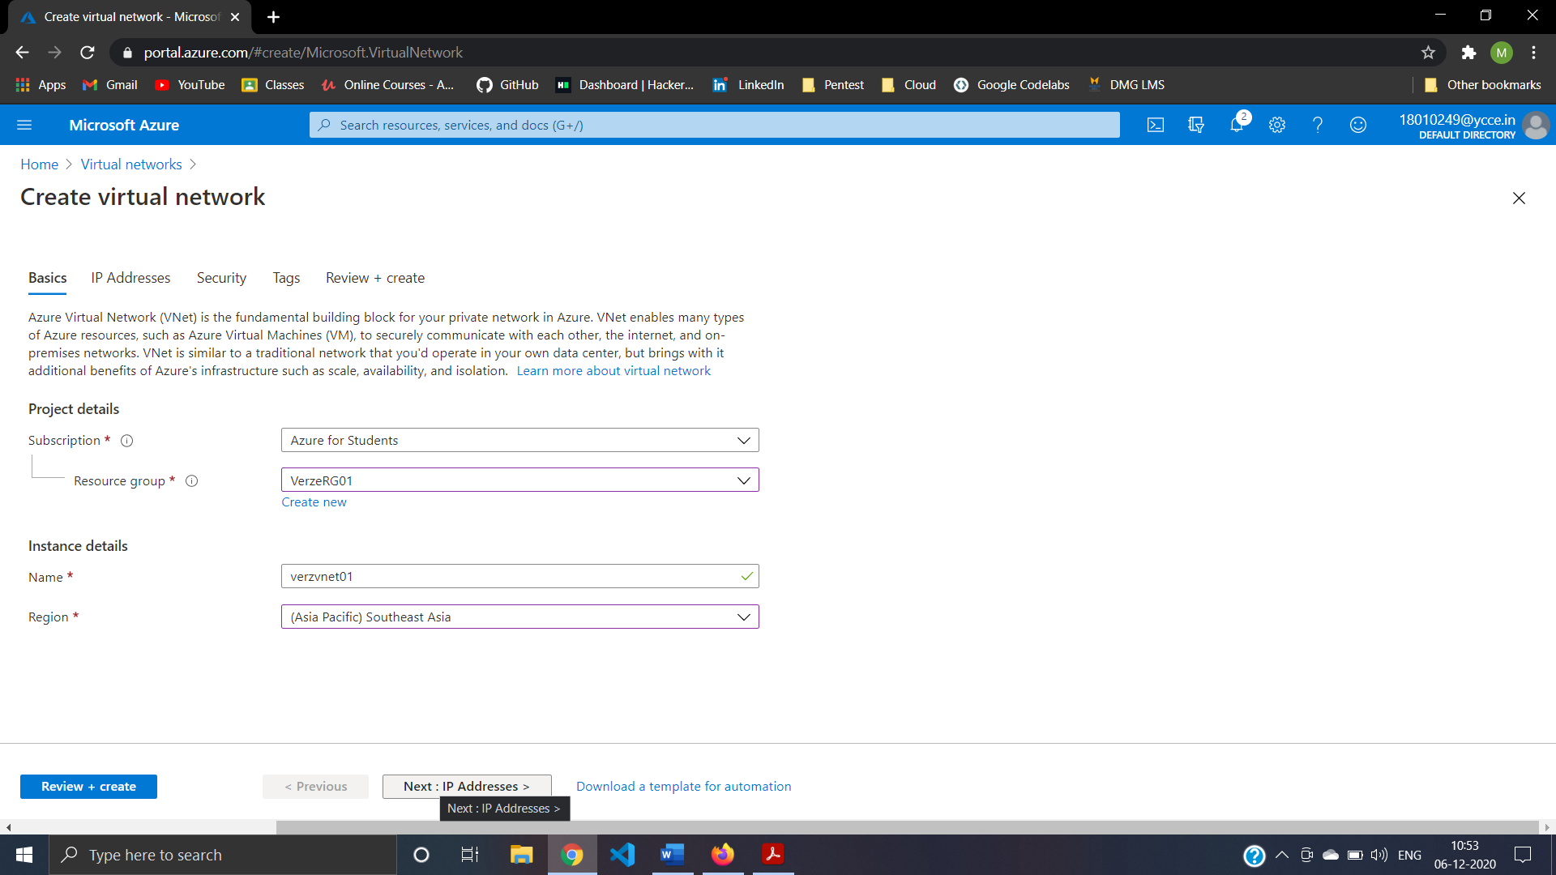

Step4:Subnet For Virtual Network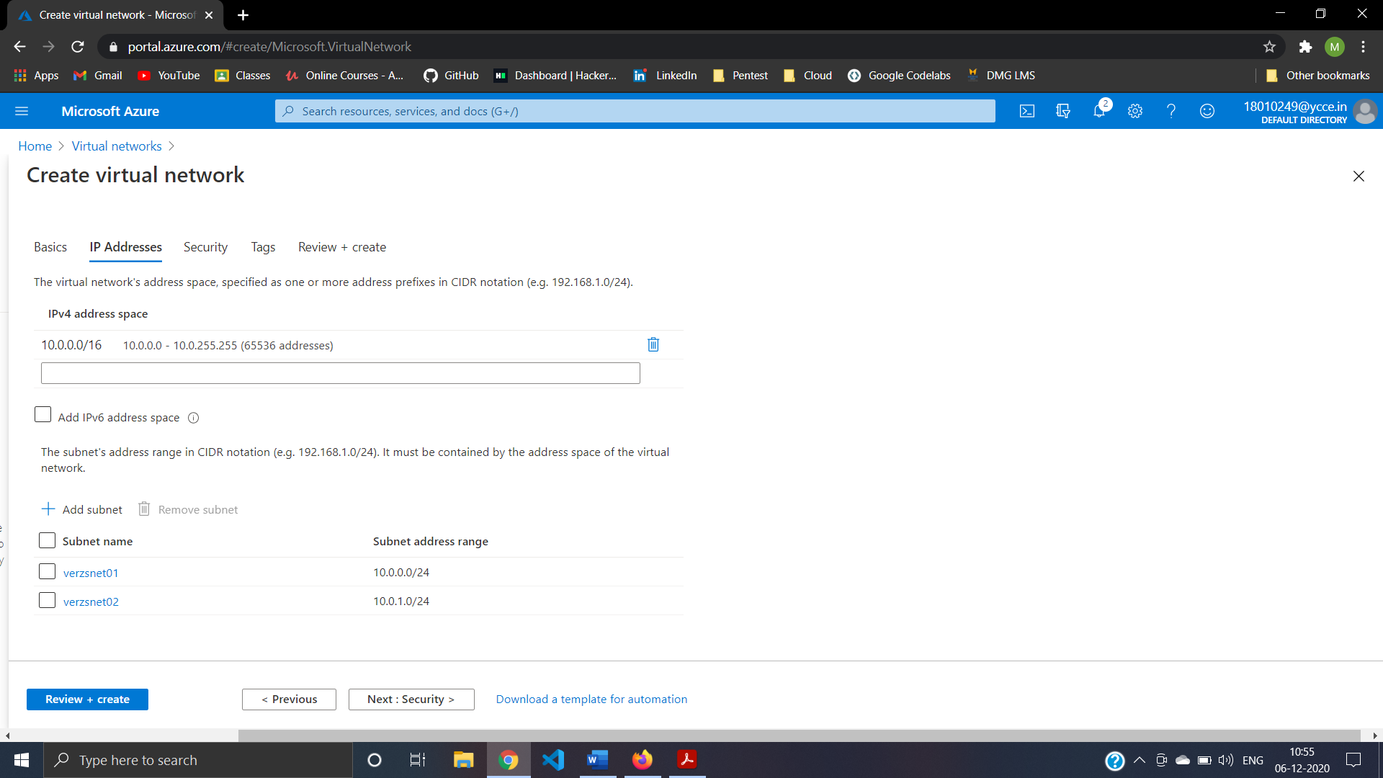

Step5:Security For Virtual Network 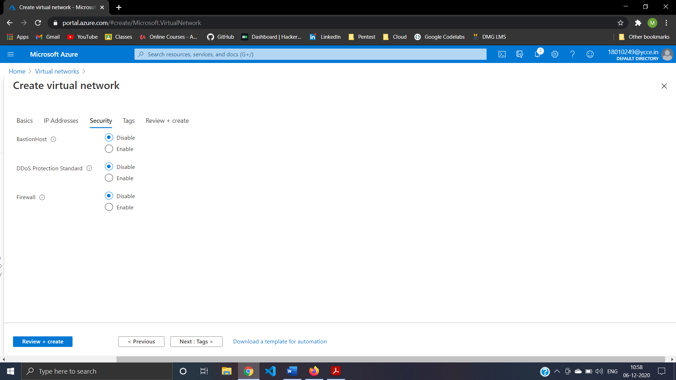

Step6:Review And Create Virtual Network 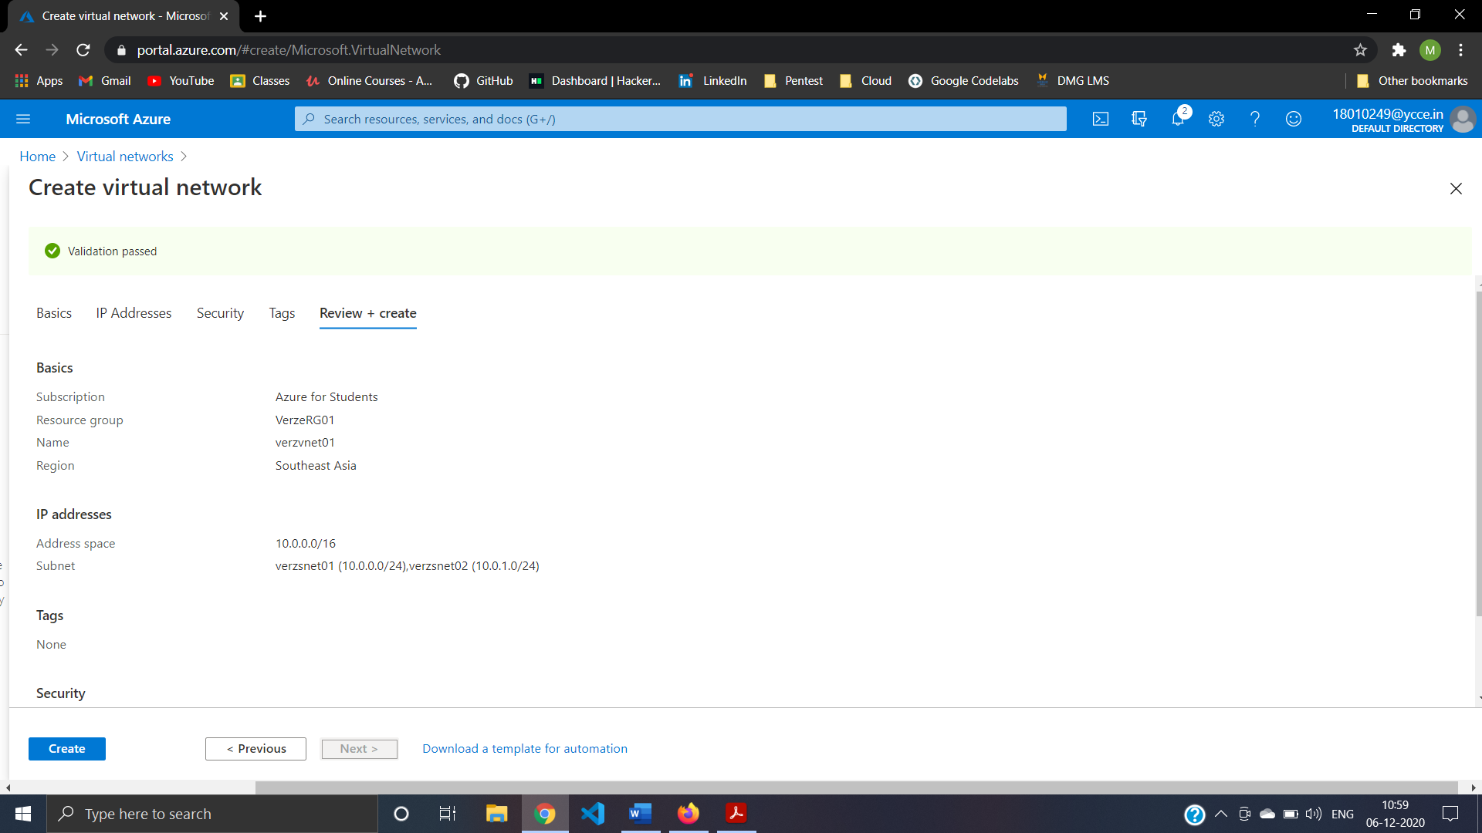

Step7:create a Virtual Machine in portal VerzVM01 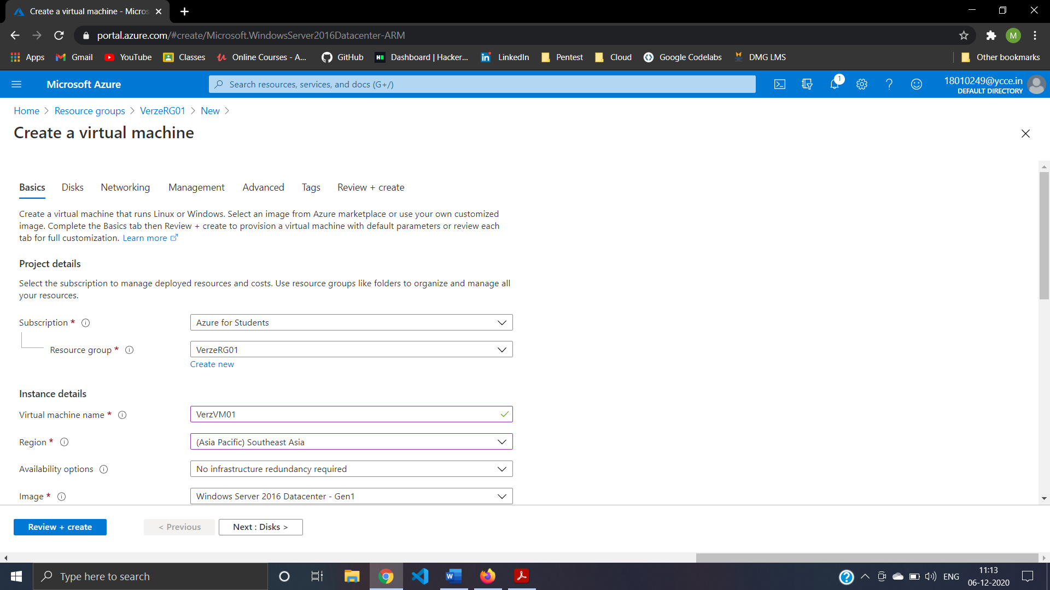

Step8:Administrator Setting For VerzVM01 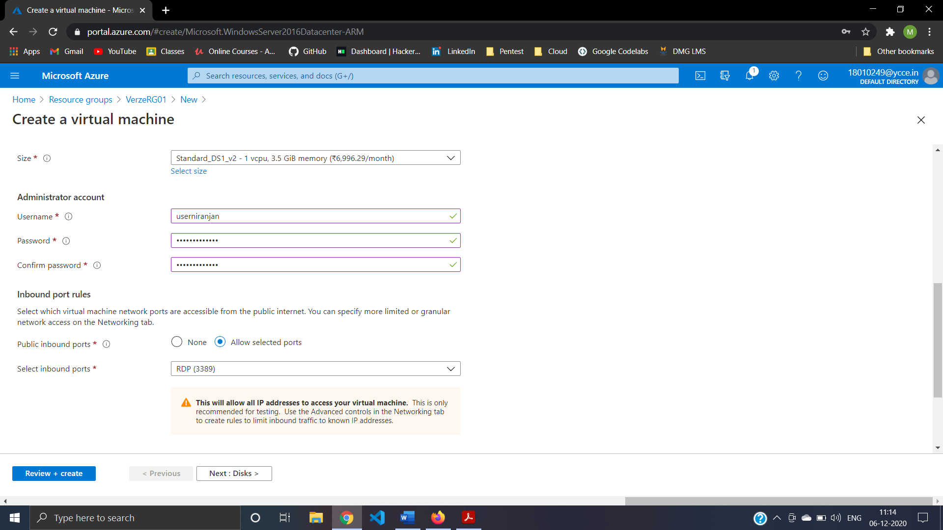

Step8:Disk Setting For VerzVM01 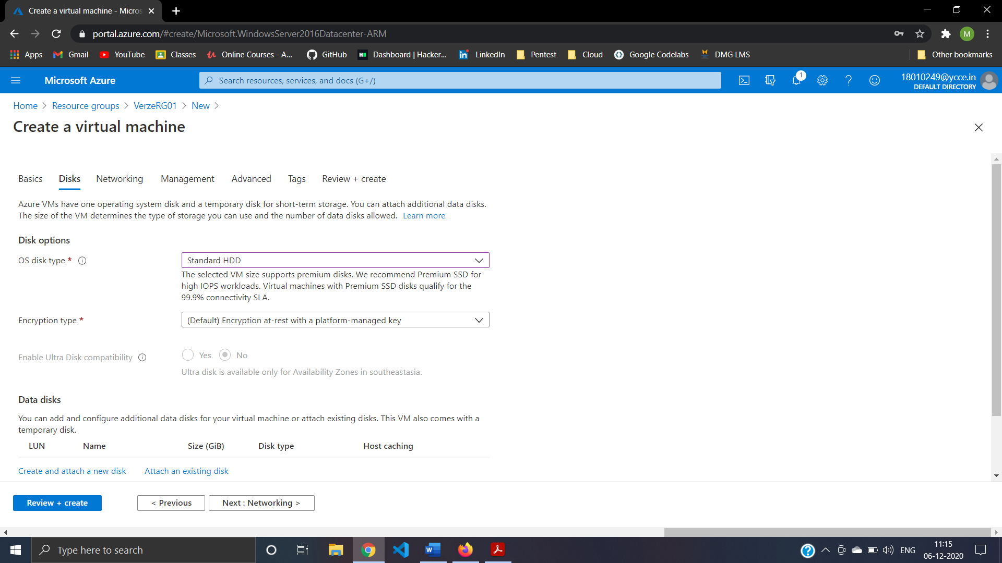

Step9:Networking Setting For VerzVM01 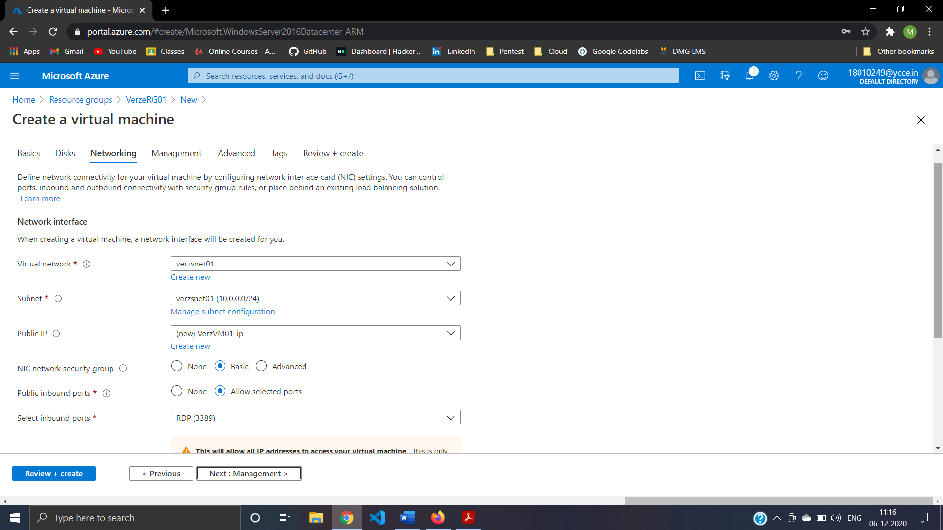

Step10:management option For VerzVM01

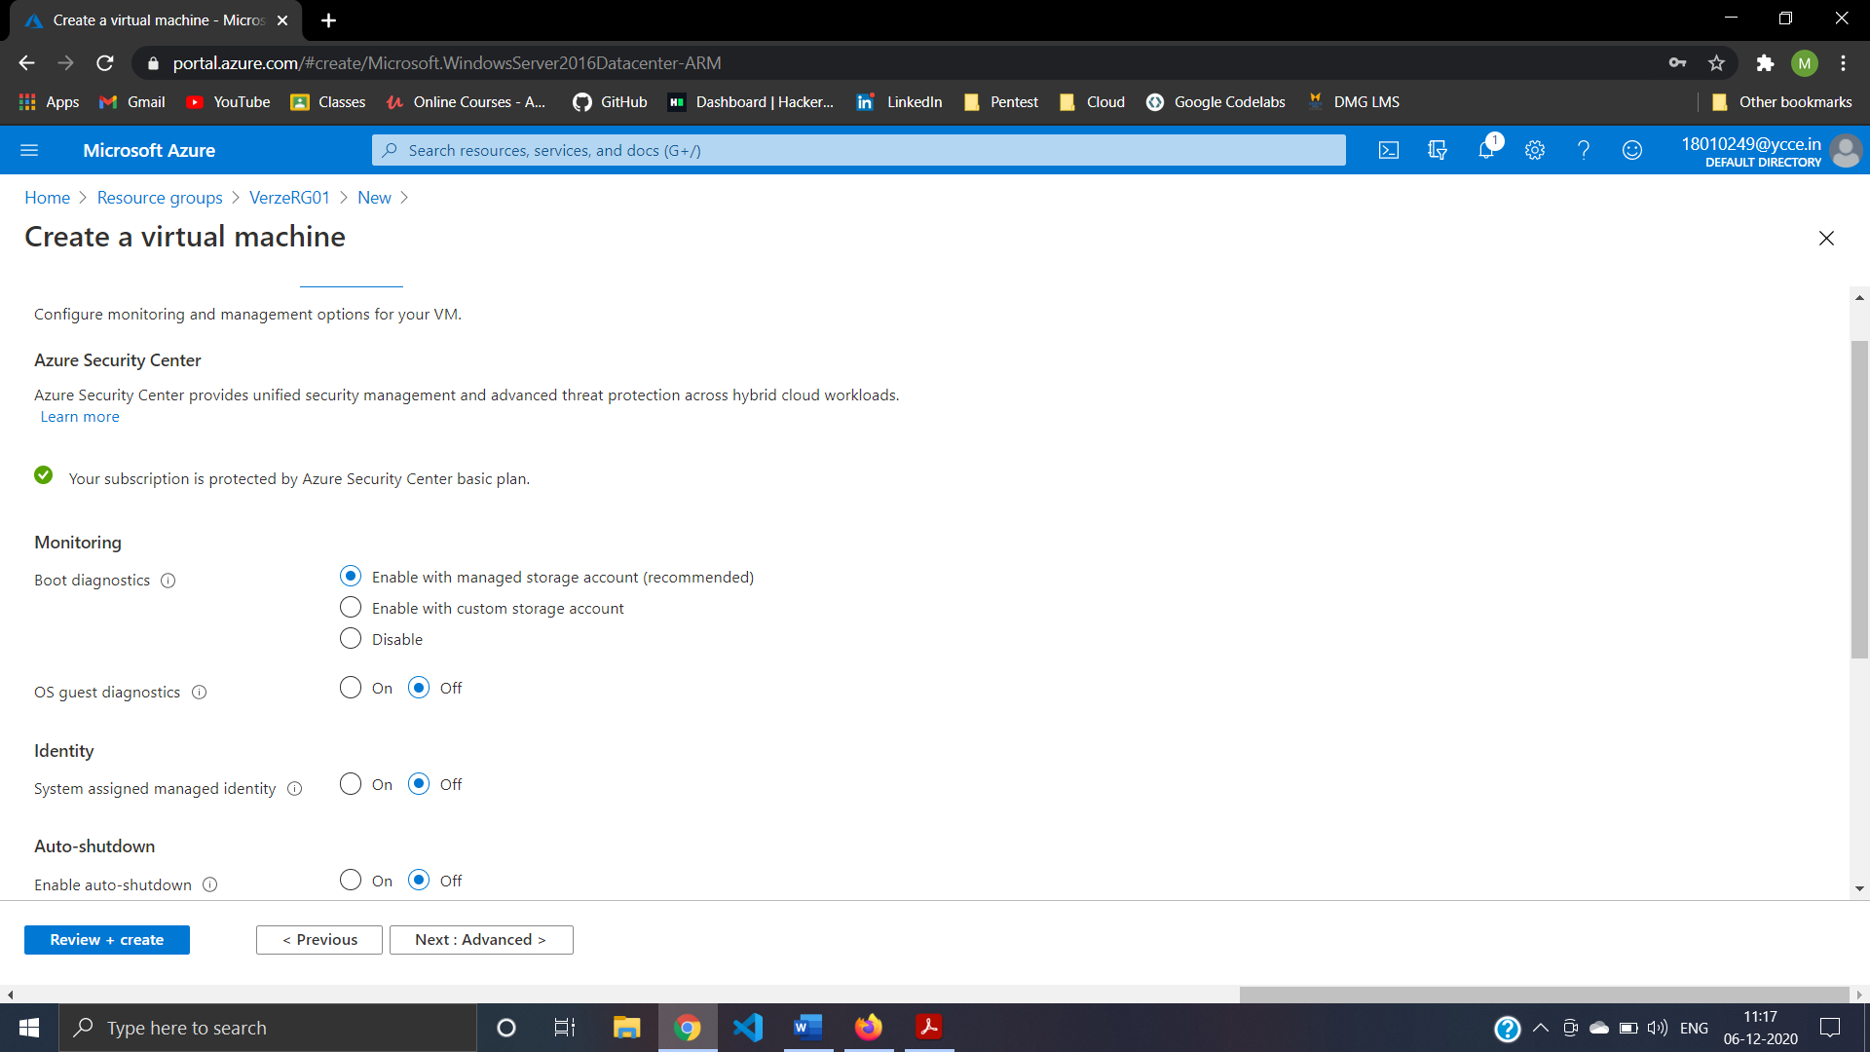

Step11:Advanced option For VerzVM01

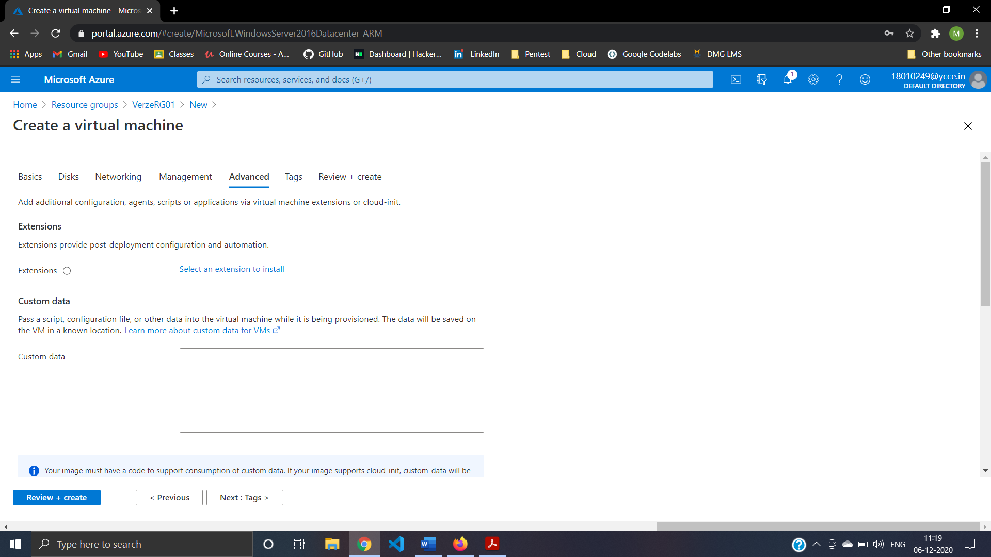

Step12:Review And Create VerzVM01 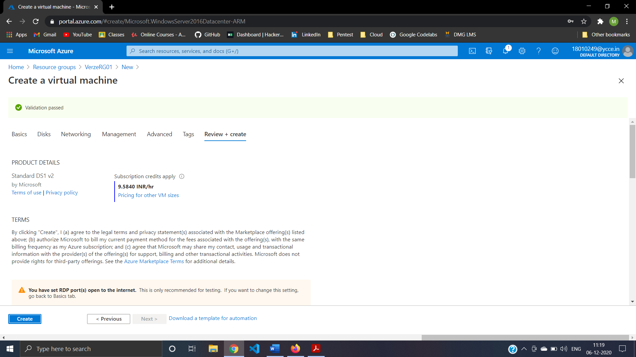

Step13:Creating Storage Account For Blob Storage (verzstorage)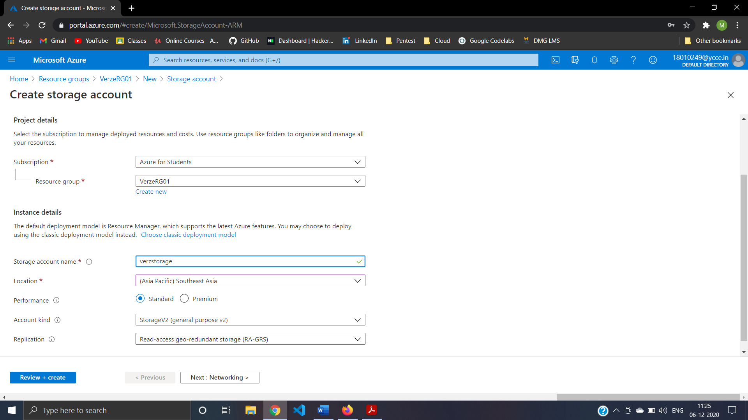

Step14:Networking For Storage Account For Blob Storage (verzstorage)

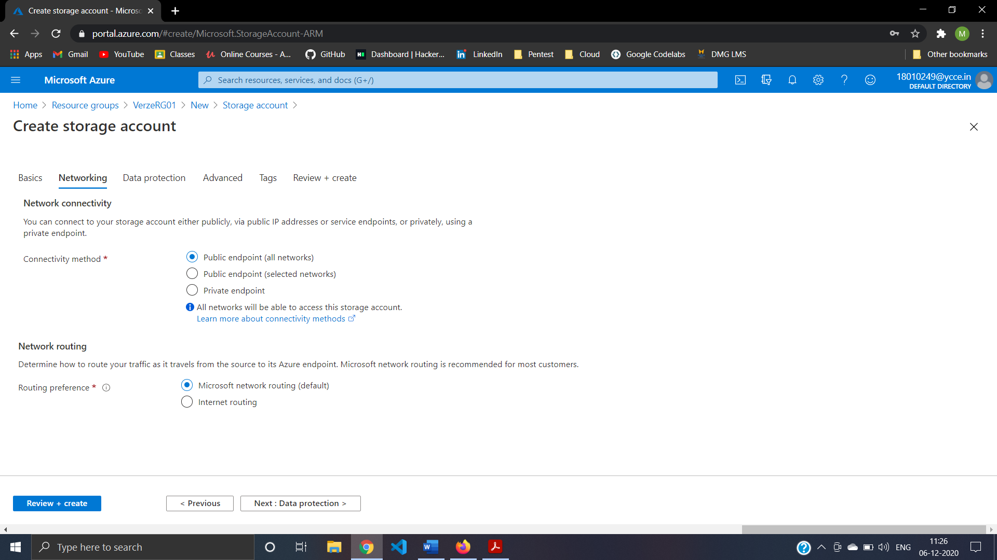

Step15:Data Protection For Storage Account For Blob Storage (verzstorage) 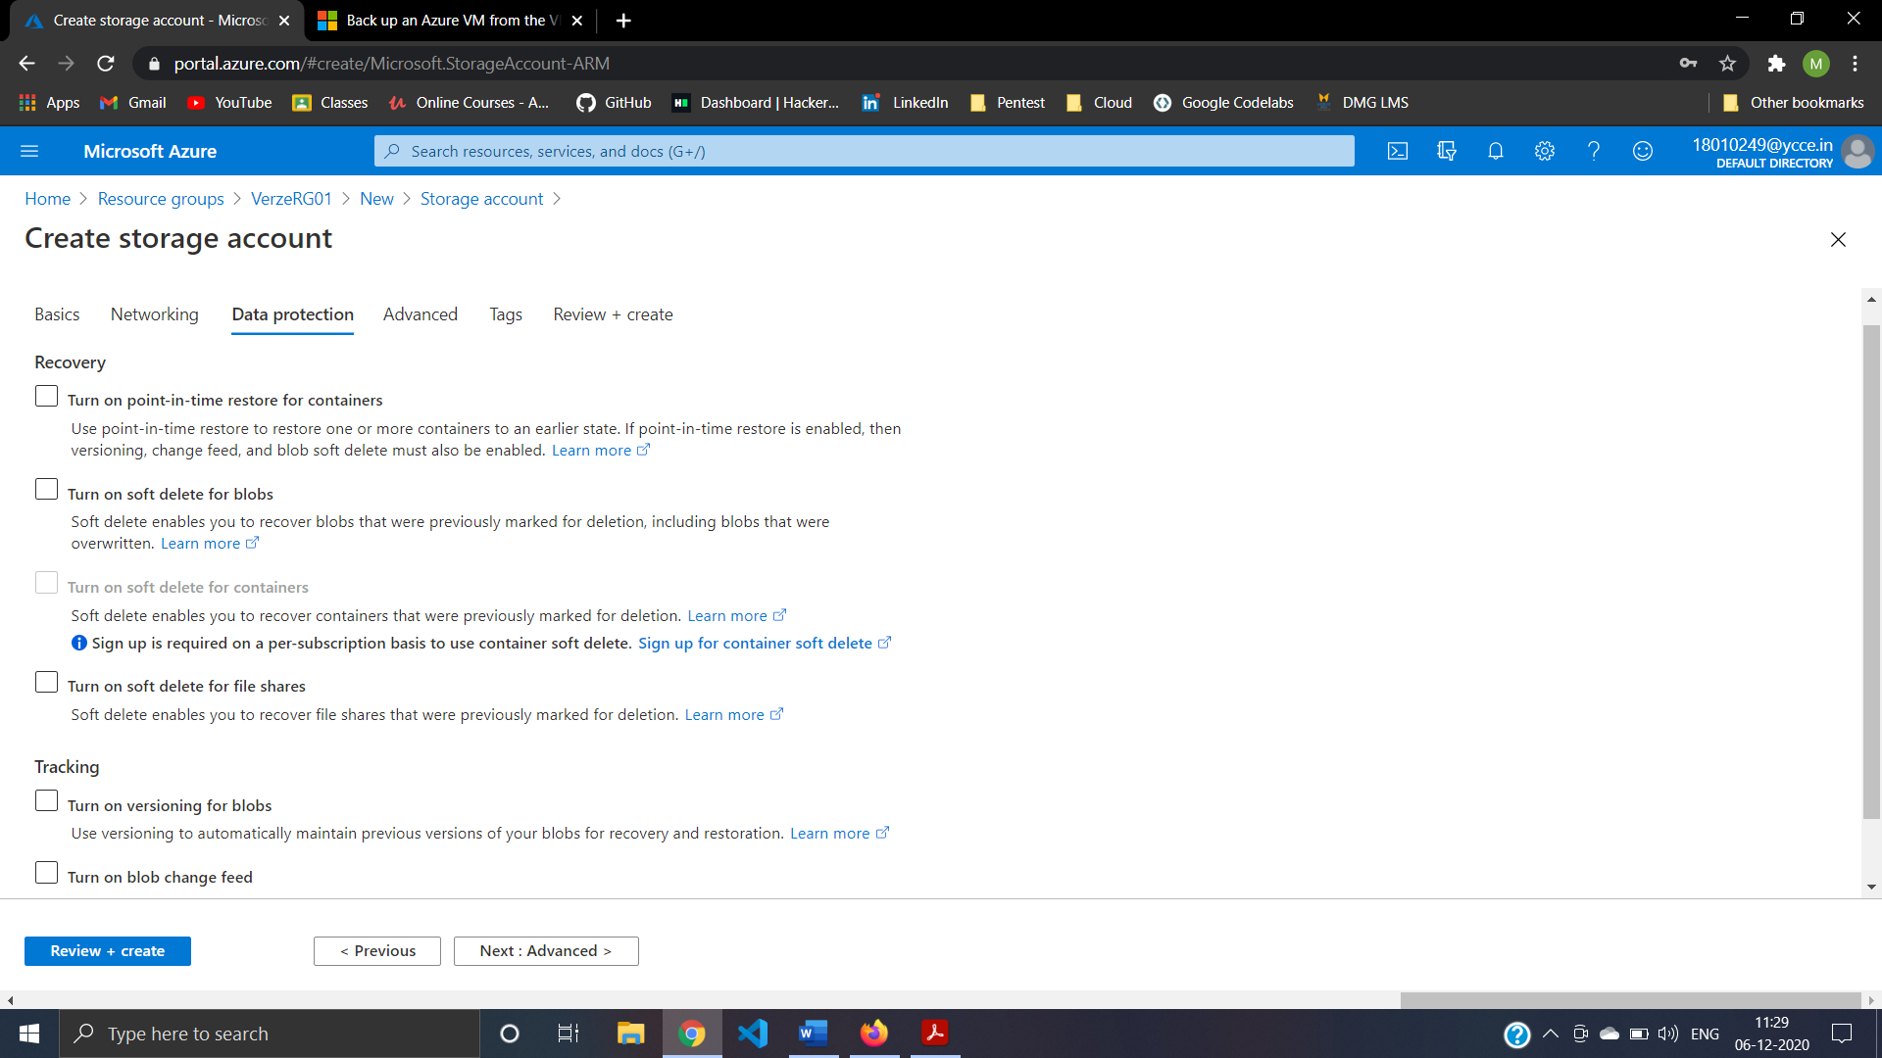

Step16:Advanced setting For Storage Account For Blob Storage (verzstorage) 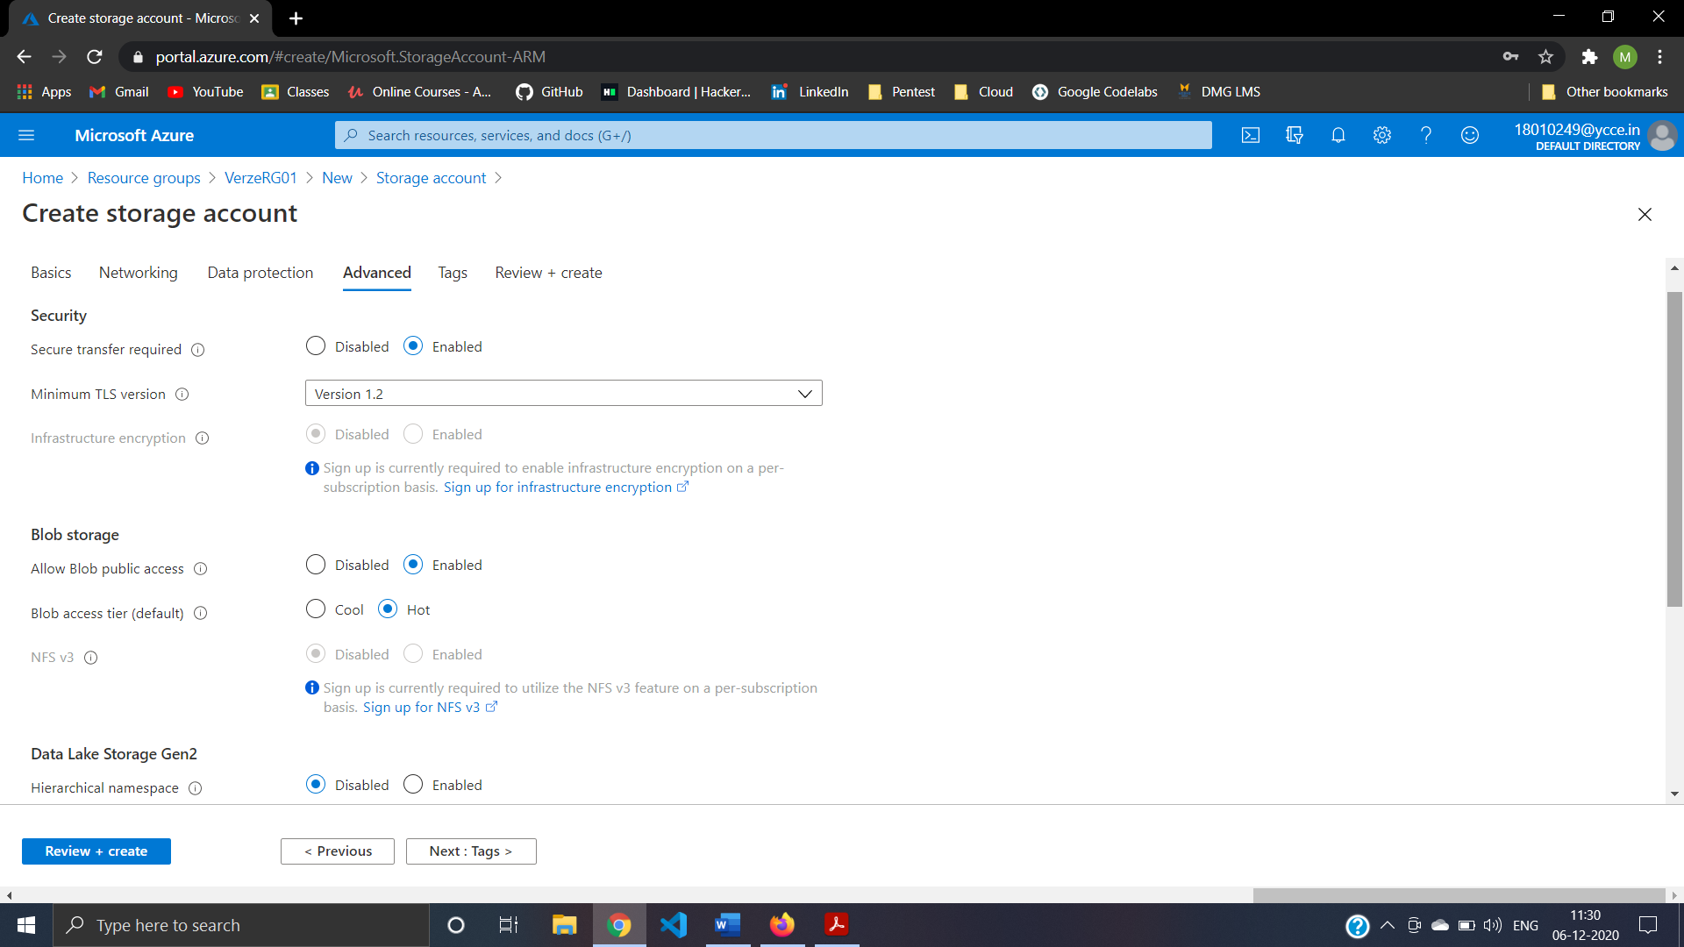

Step17:Review And Create Storage Account For Blob Storage (verzstorage) 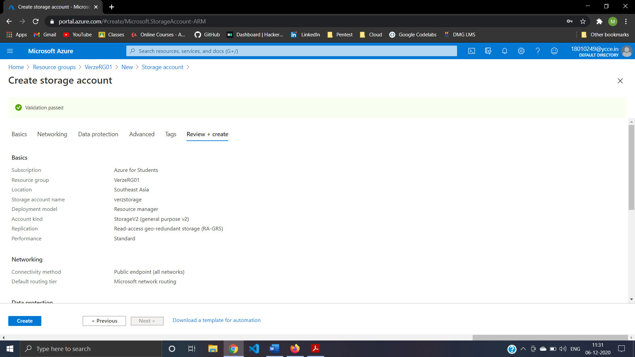

Step18:Create Blob Storage (verzstr01) 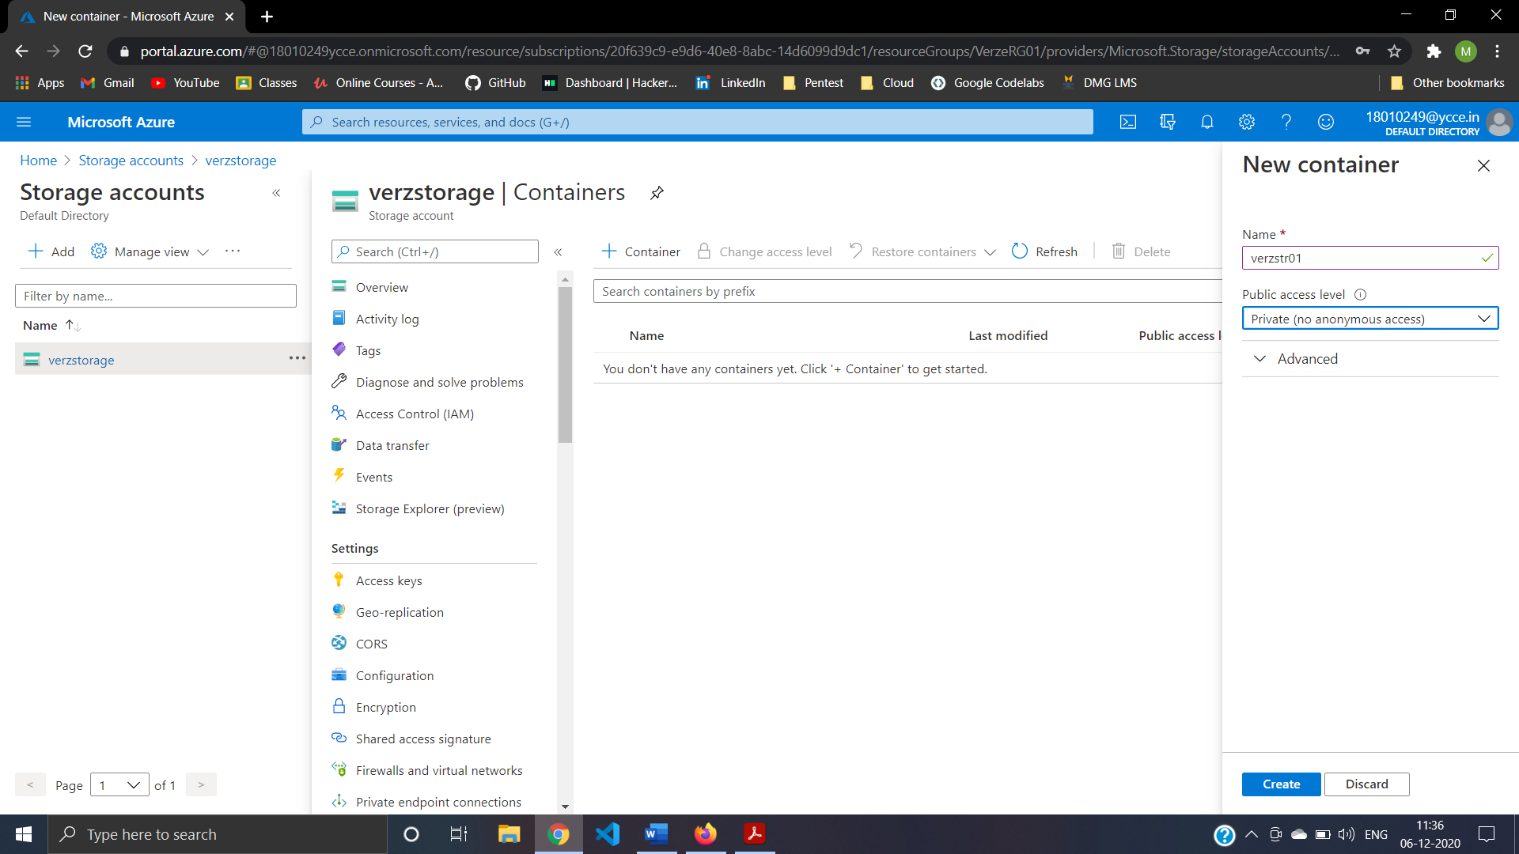

Create 19: create File share verzfs01

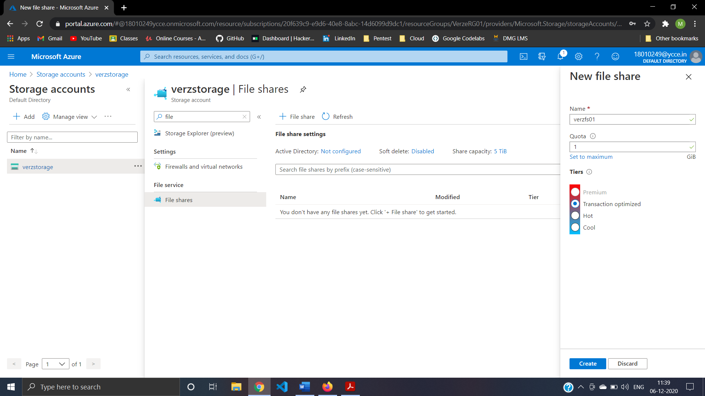

Create 20: uploading File in File share verzfs01 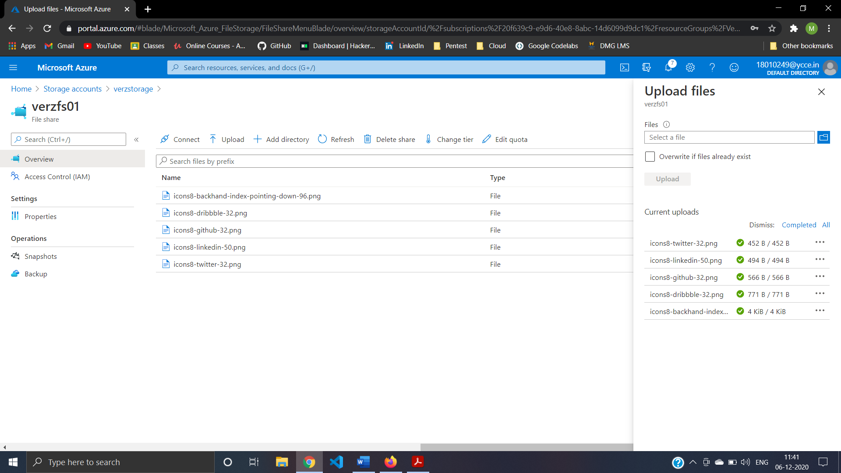

Create 21: Connecting To VerzVM01 using RDP File

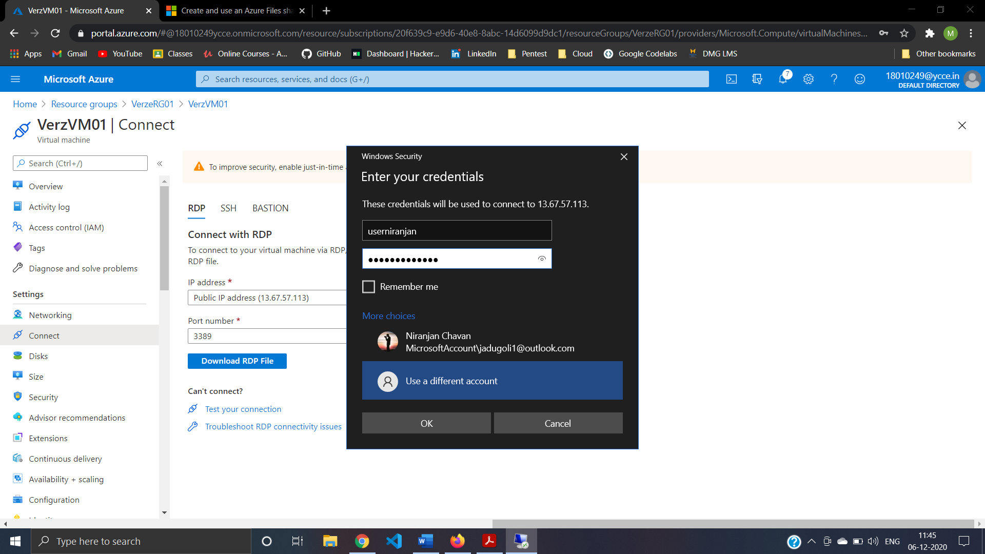

Step22:verify Certificate For VerzVM01 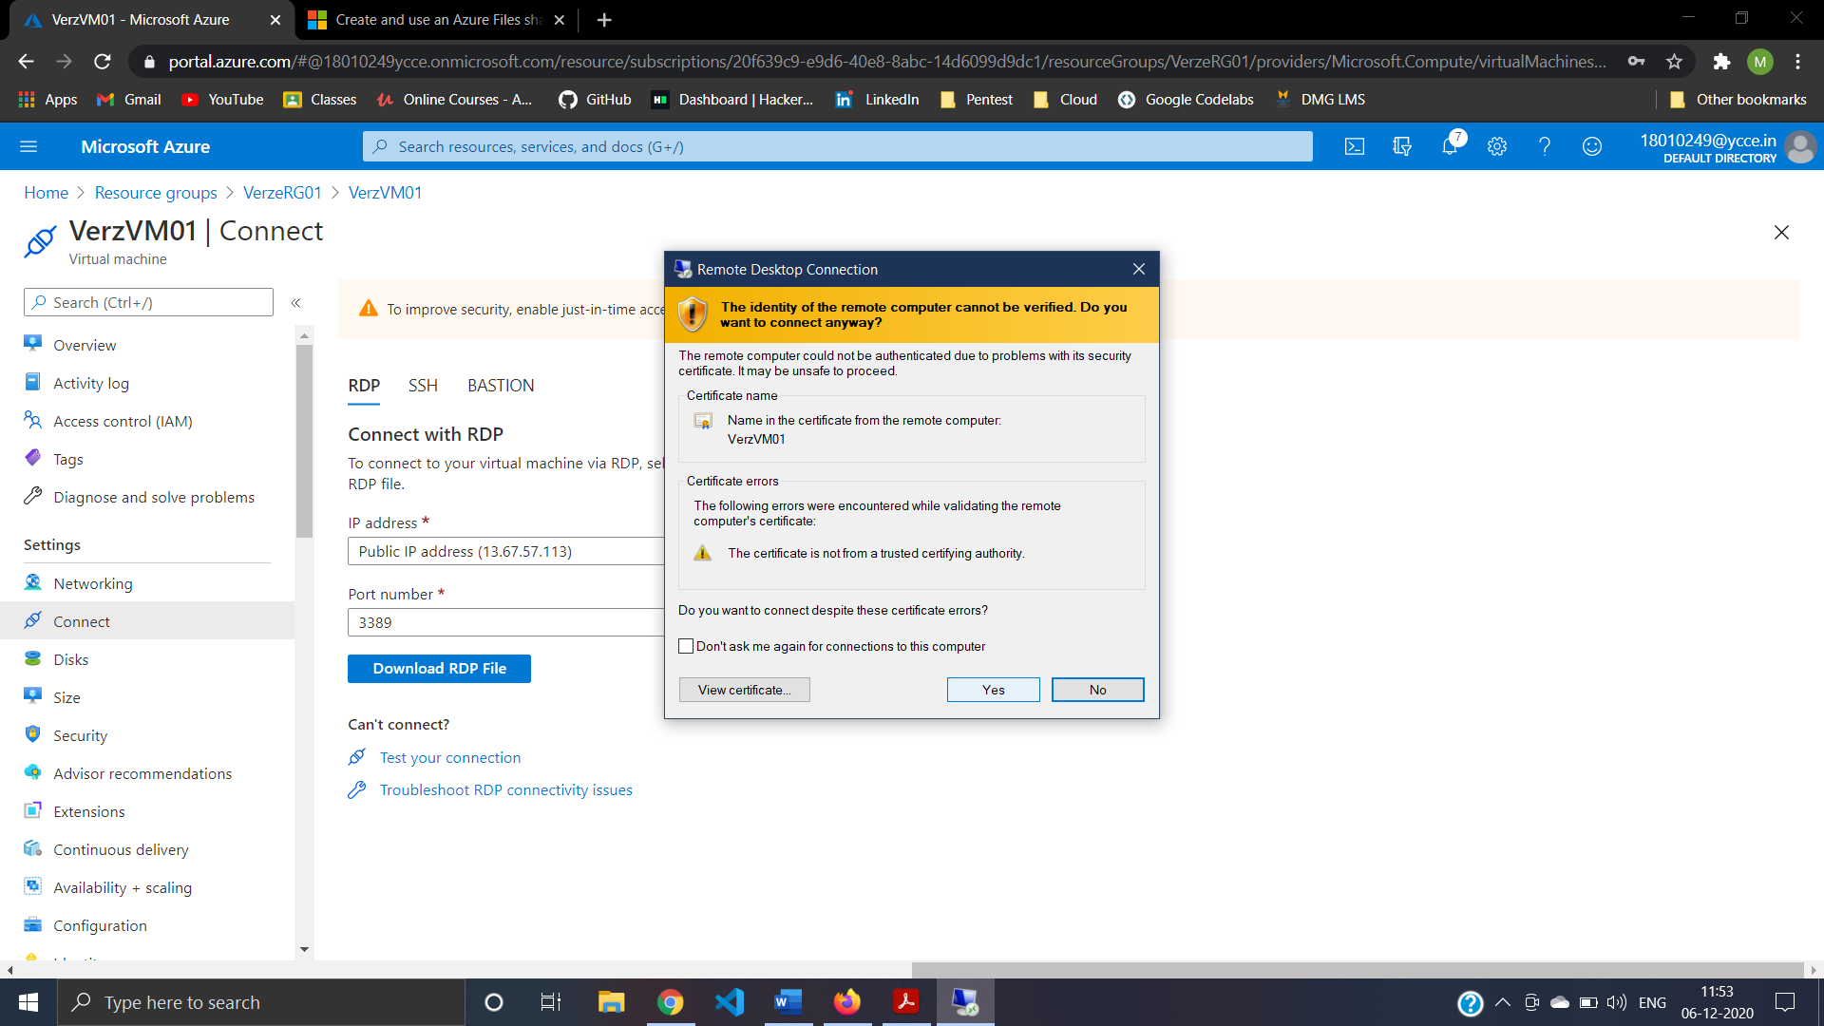

Step22:Successfully logon to VerzVM01 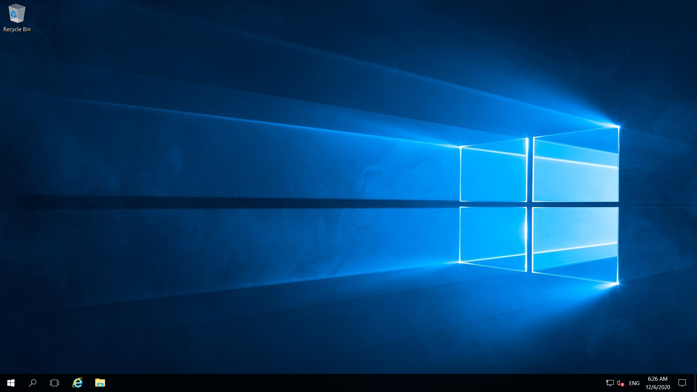

Step23:Connect To File Share verzfs01 and Copy Storage Account key to note pad 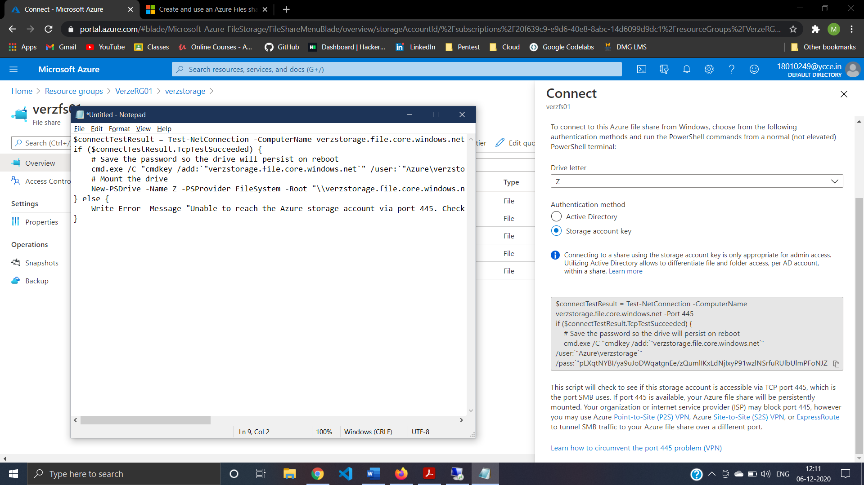

Step24:Mount File Share verzfs01 To VerzVM01

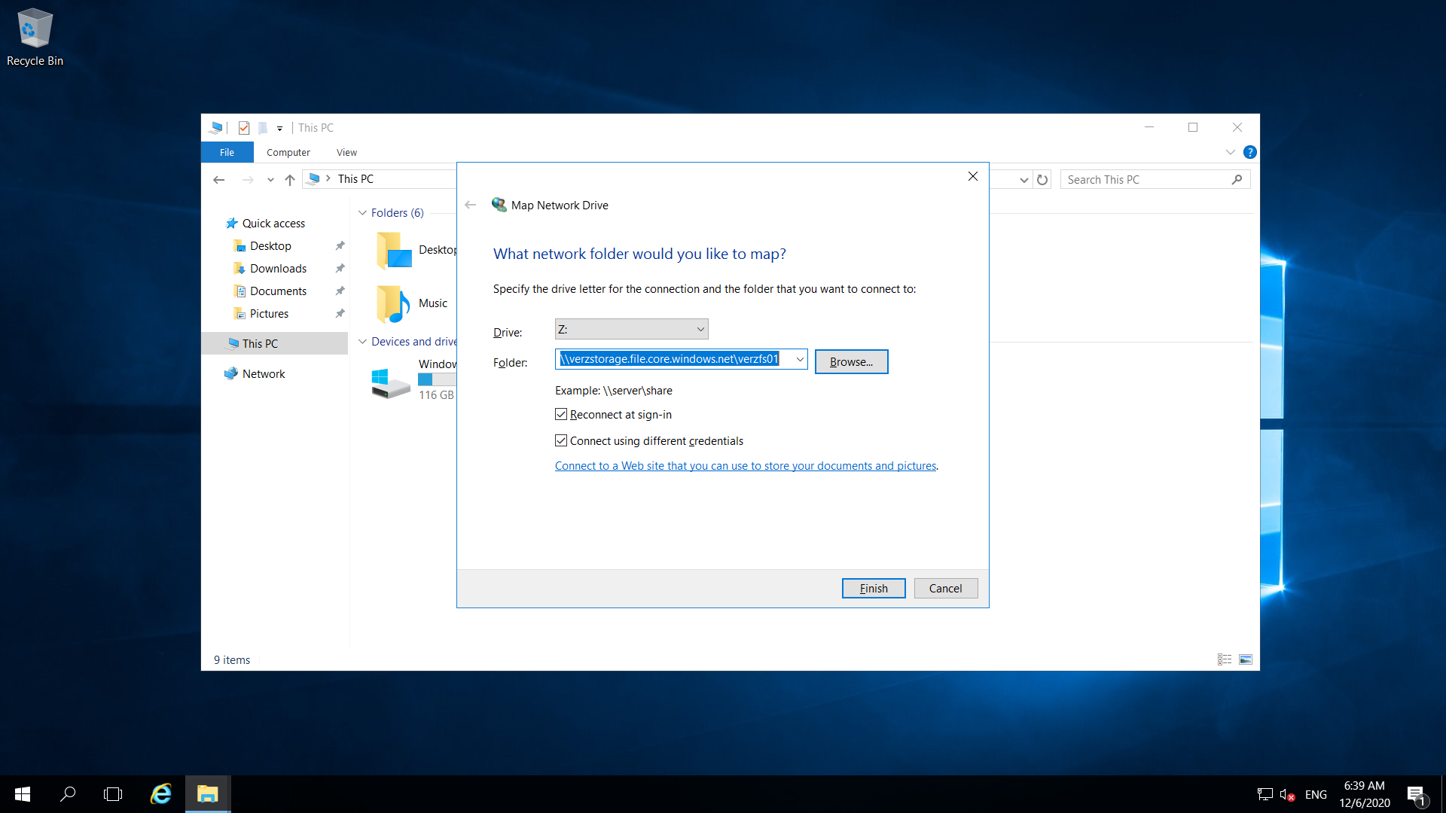

Step25:connect File Share verzfs01 From VerzVM01 using ntwork Credentials

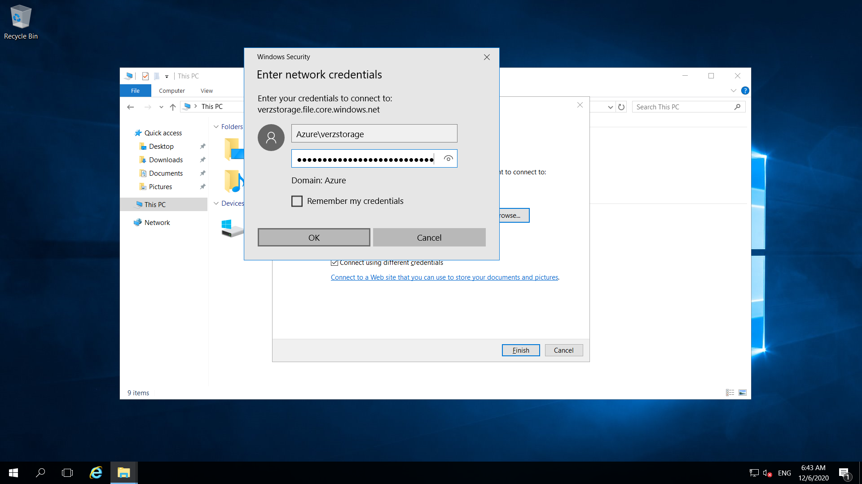

Step26: Successfully connect File Share verzfs01 From VerzVM01 i.e Create a File Share (Verzfs01)and mount on the (VerzVM01)

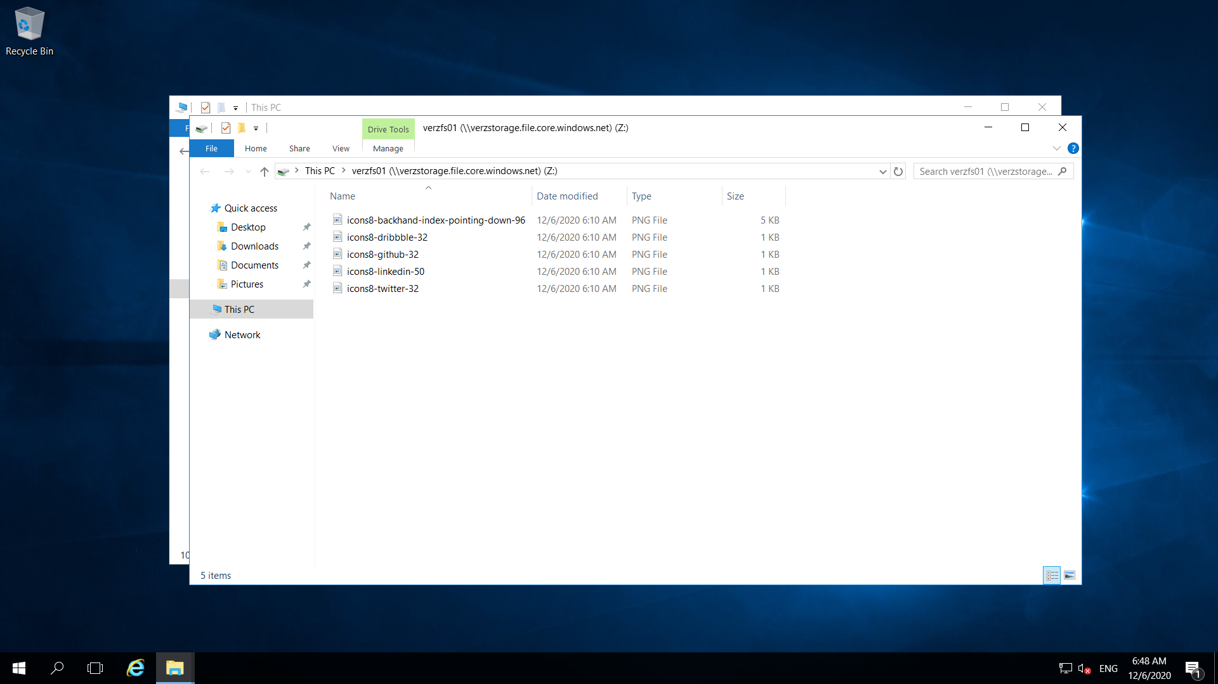

Step27: Create NSG verznsg

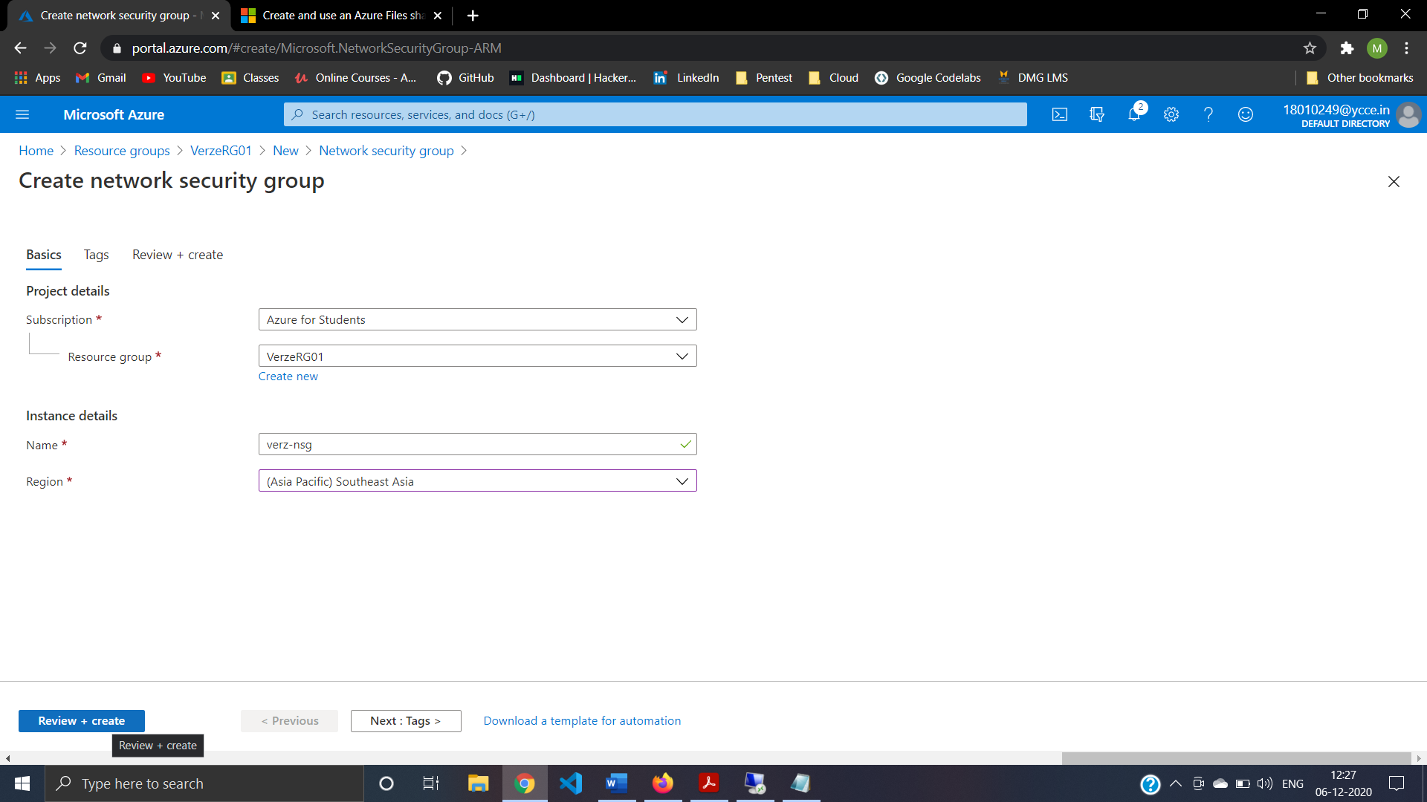

Step28: Review and Create verznsg 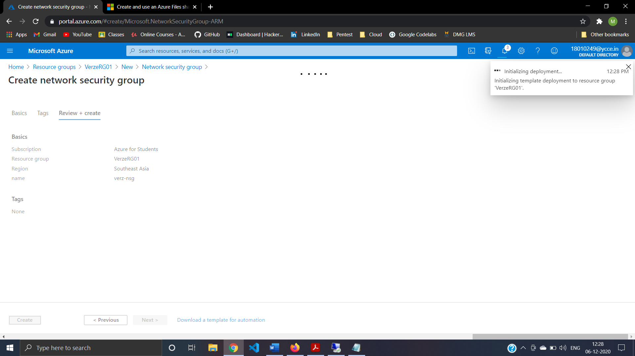

Step29:Configure inbound security port rule to allow RDP

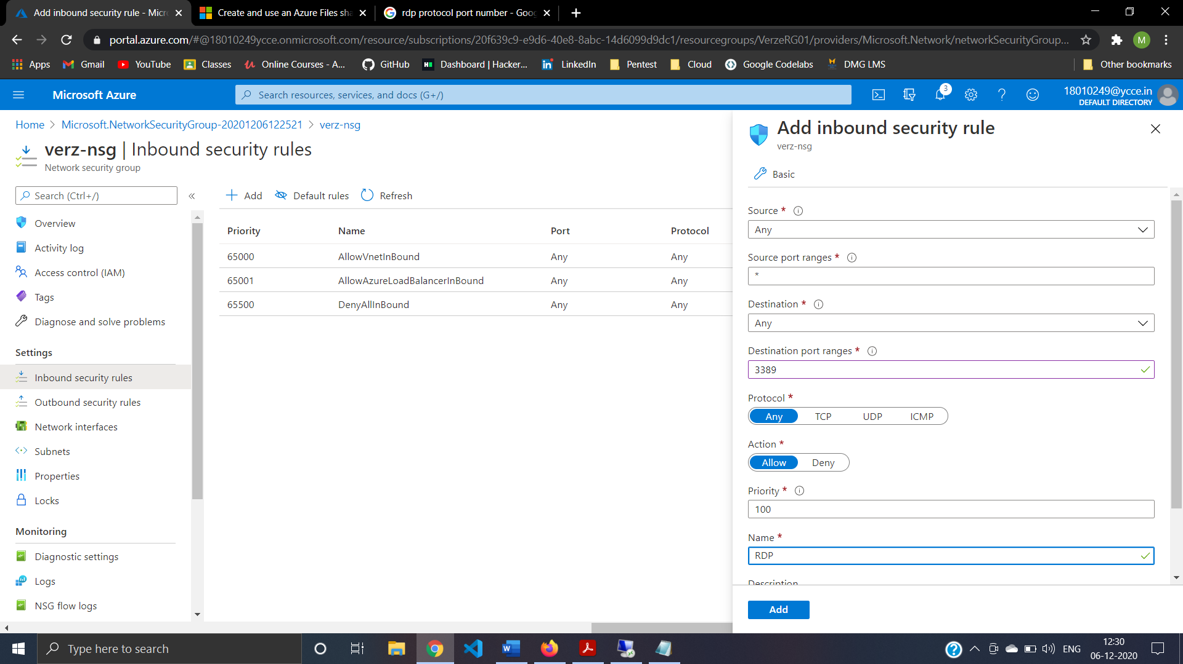

Step30:Configure outbound security port rule to deny internet acess 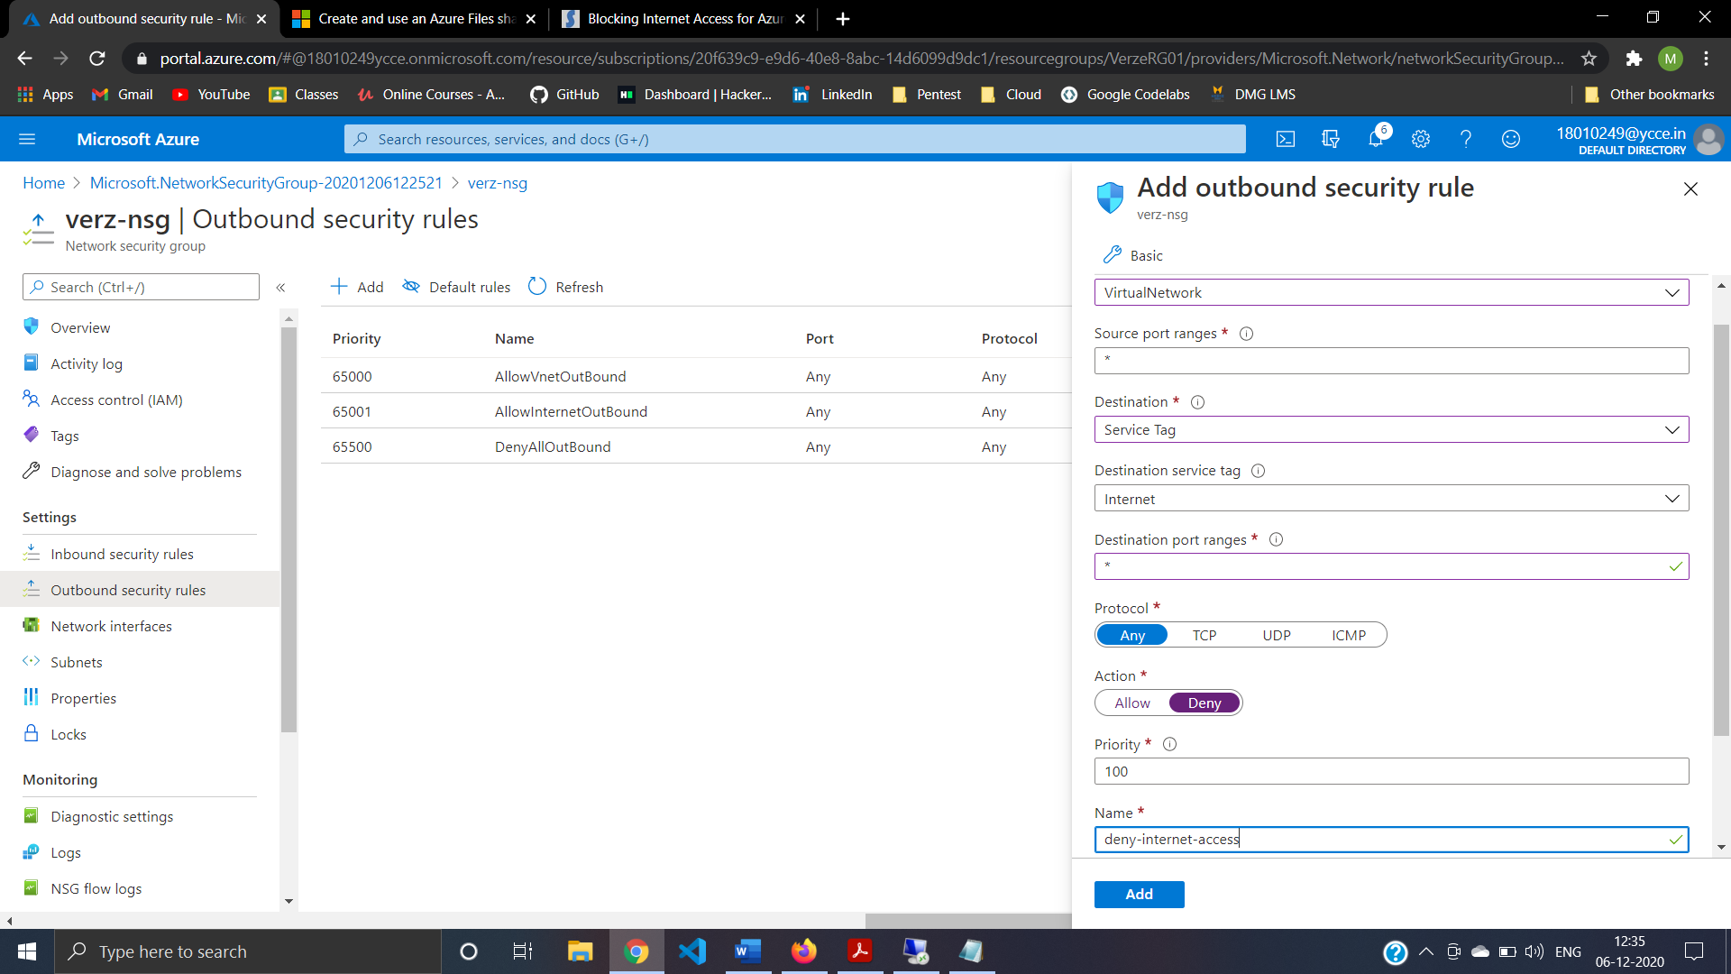

Step31:Creating New Policy Using Conditional access By location 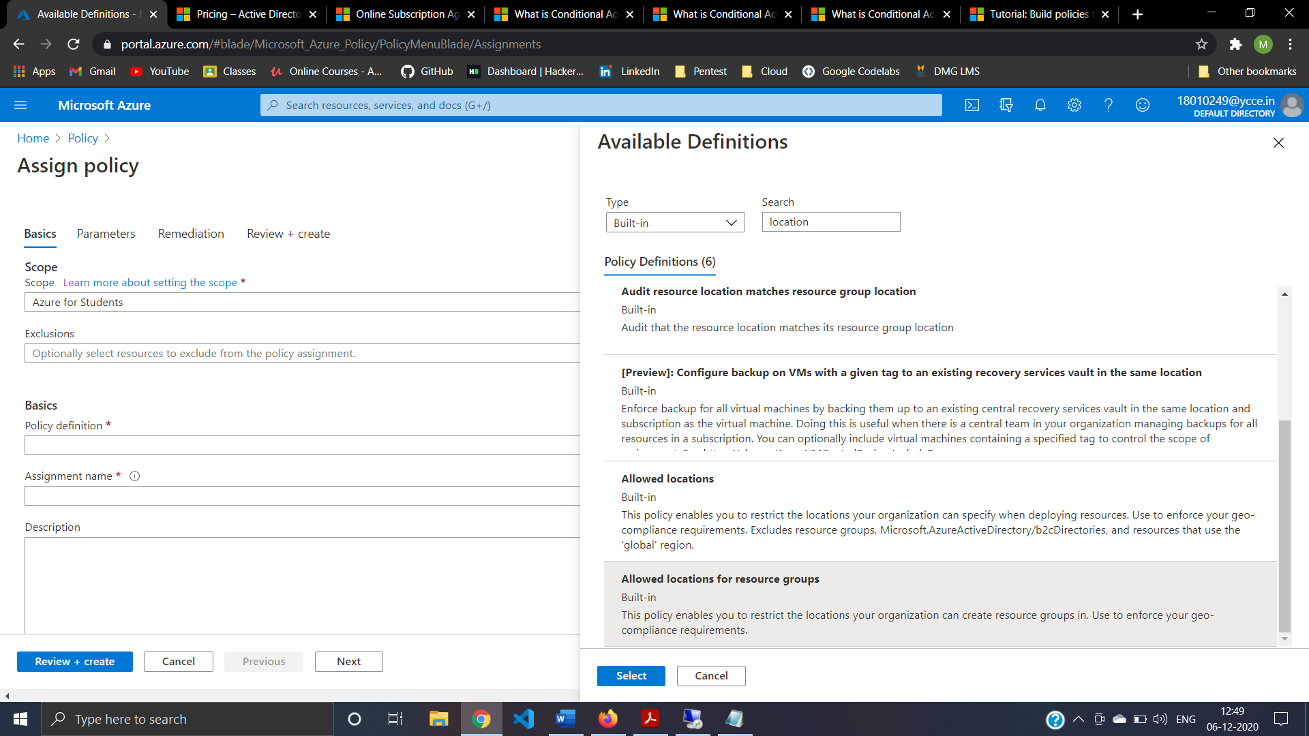

Step32:Configuring policy details 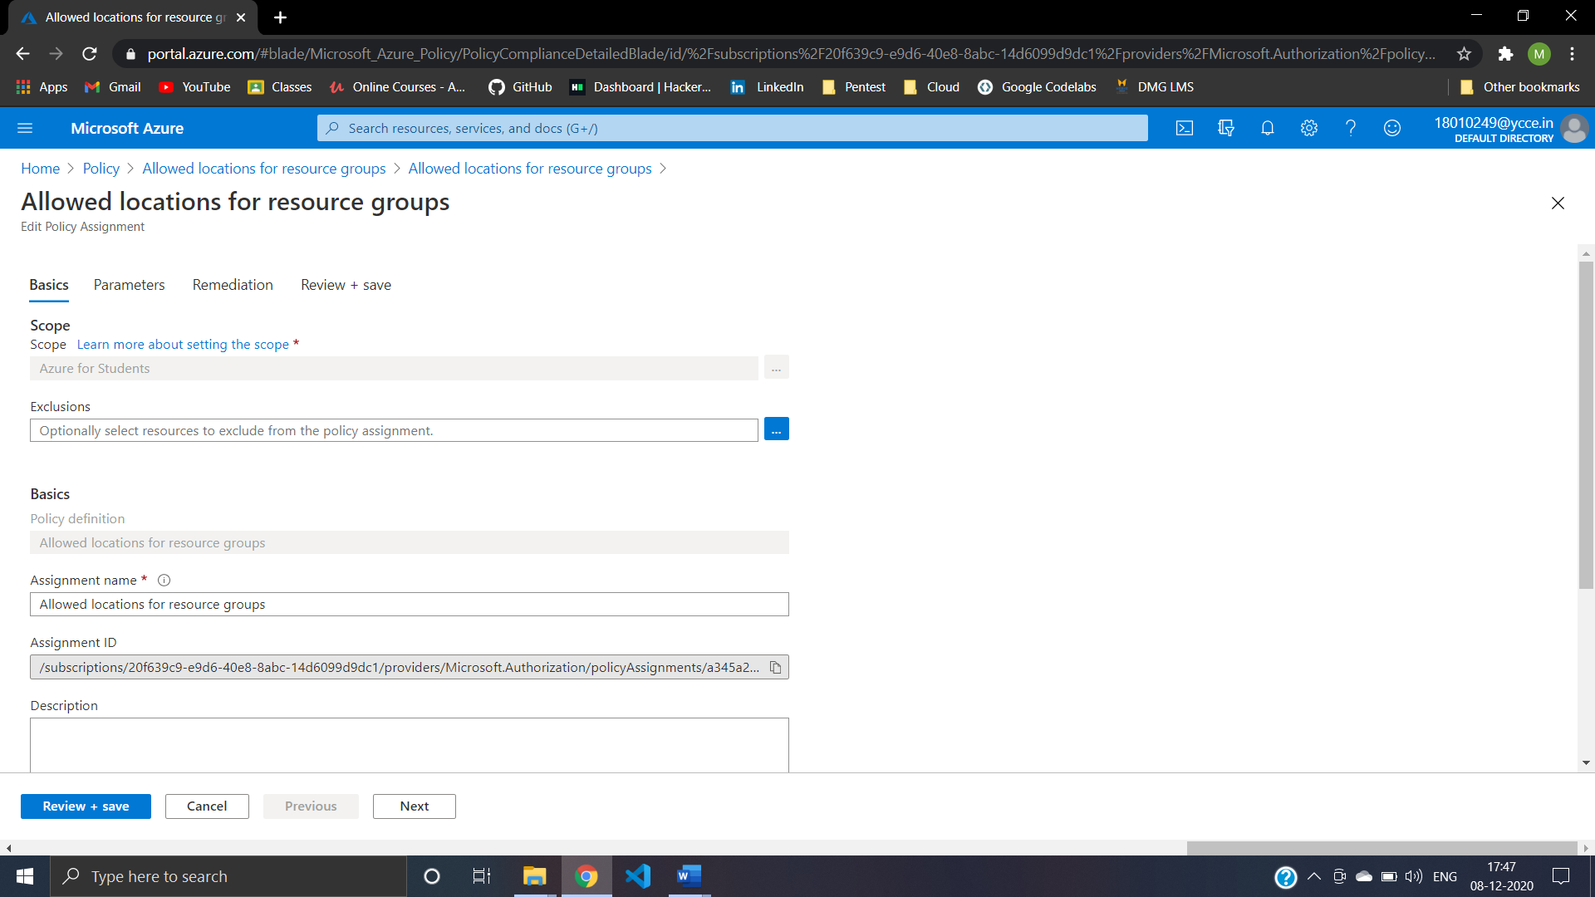

Step33:Configuring parameter for policy 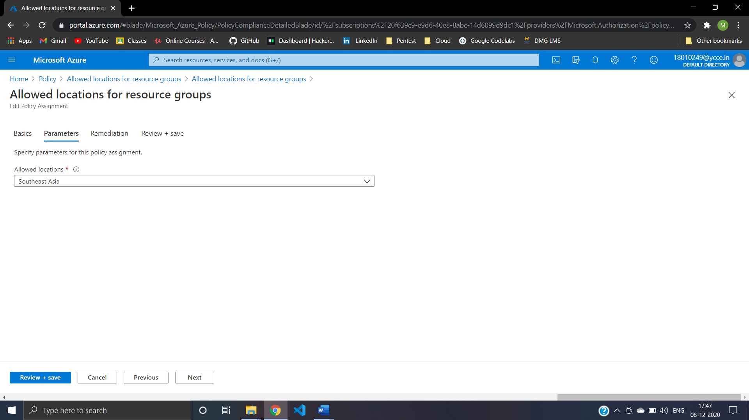

Step34:Remediation for policy 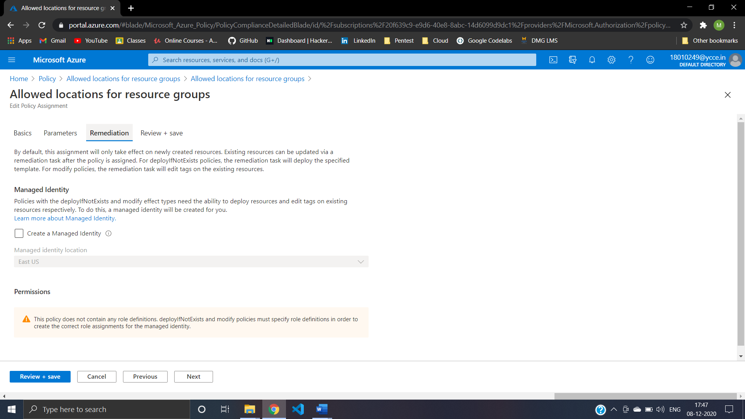

Step35:Review And Create Policy 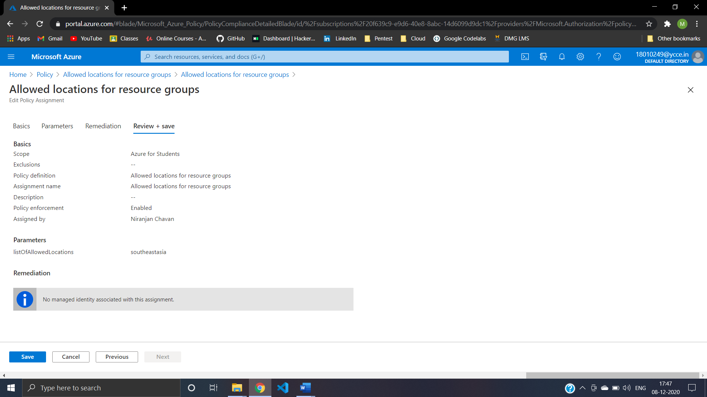

Step36:Compliance state is ready 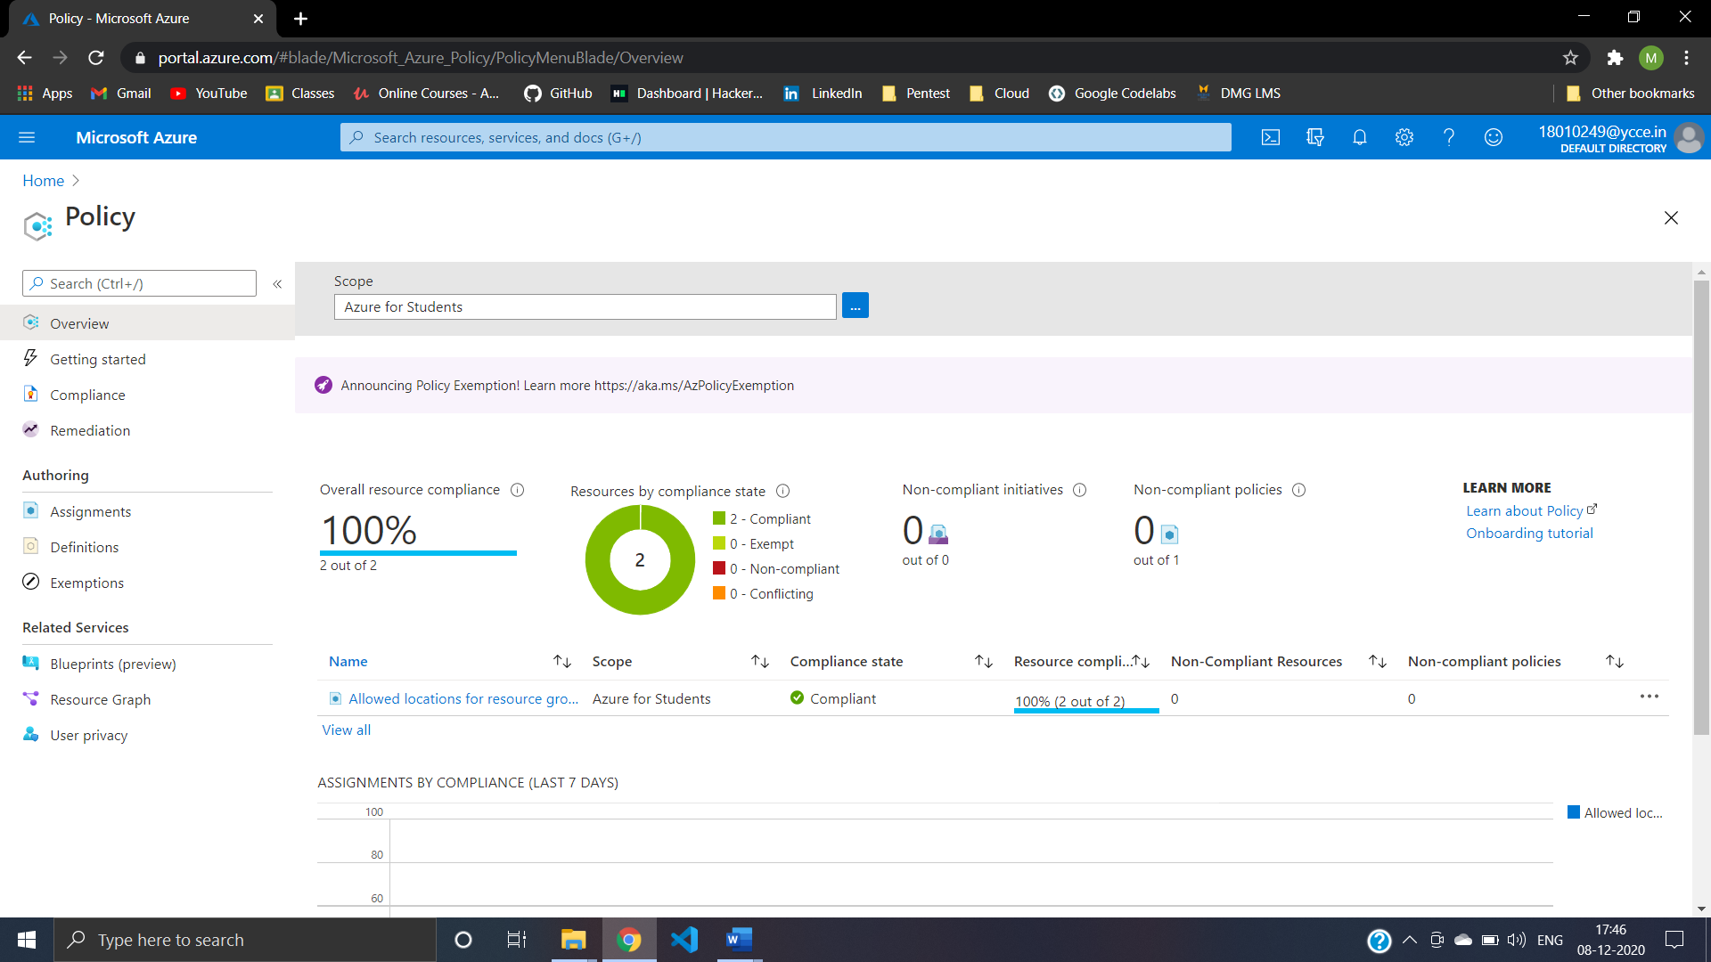

Step37:trying To create Resource in another region

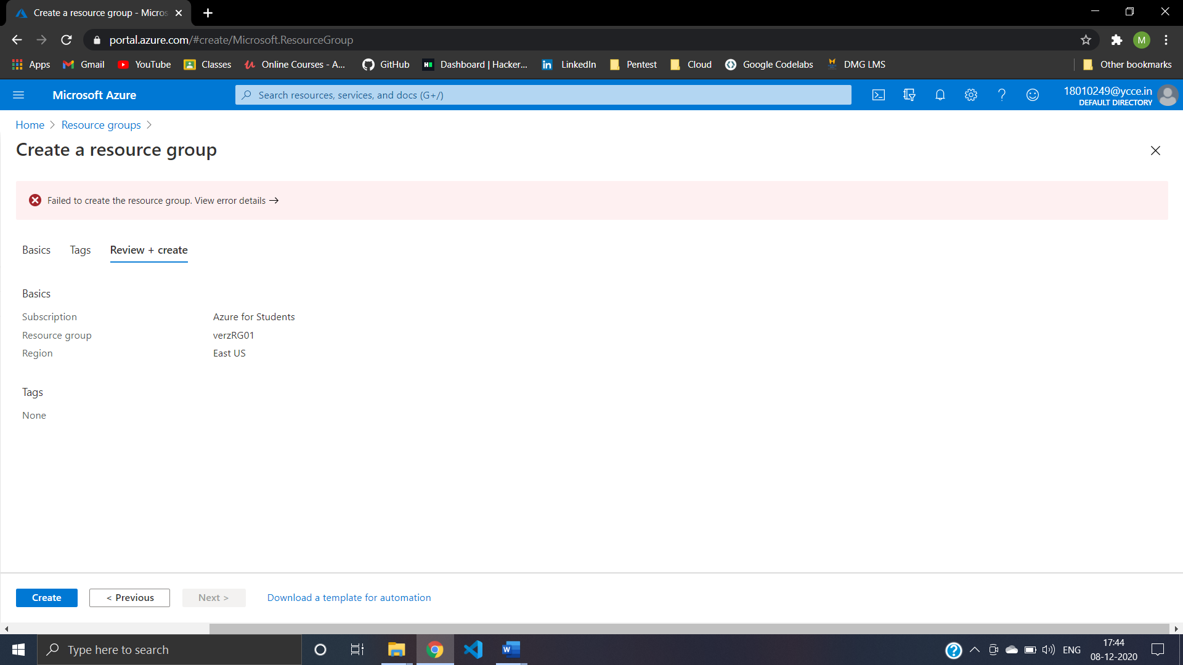

Step38:create lock to Resource Group for Delete 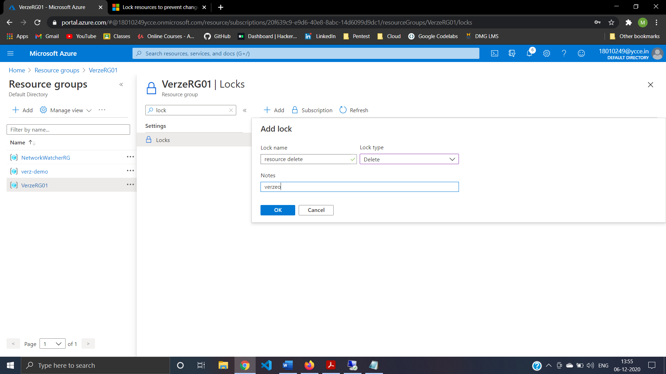

Step39:Apply lock to Resource Group for Delete failde to delete

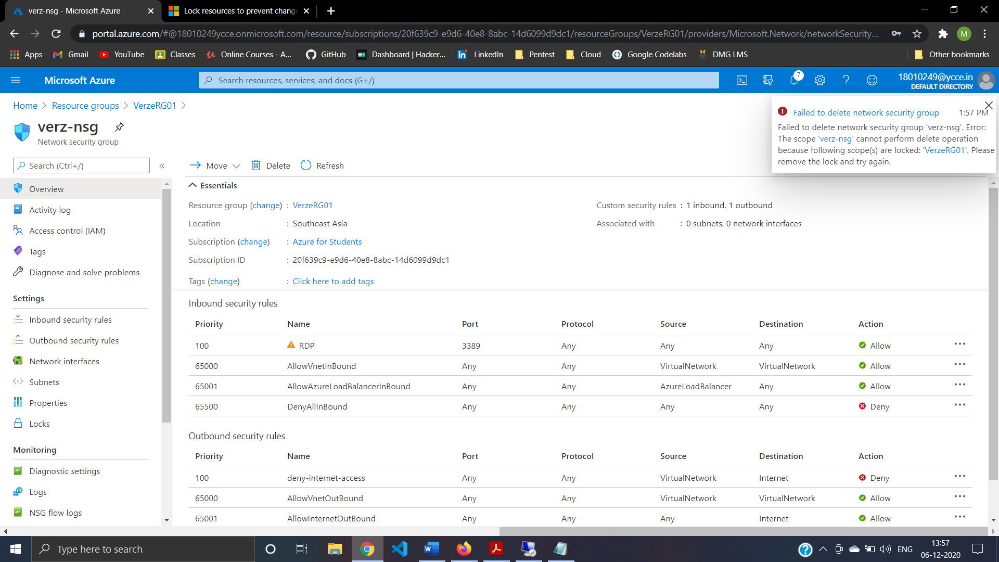

Step40:Configure Alert Rule For VerzVM01

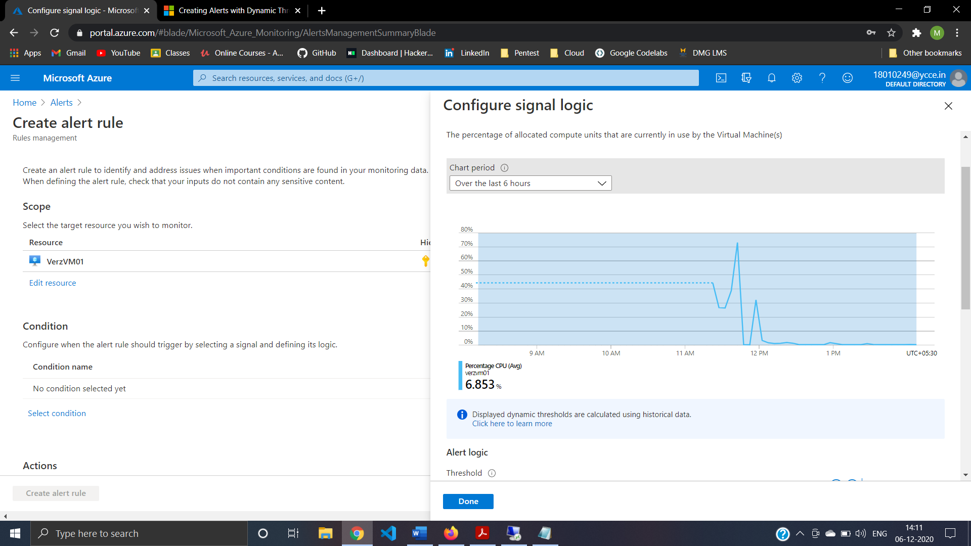

Step41:Configure Alert Rule For VerzVM01 step

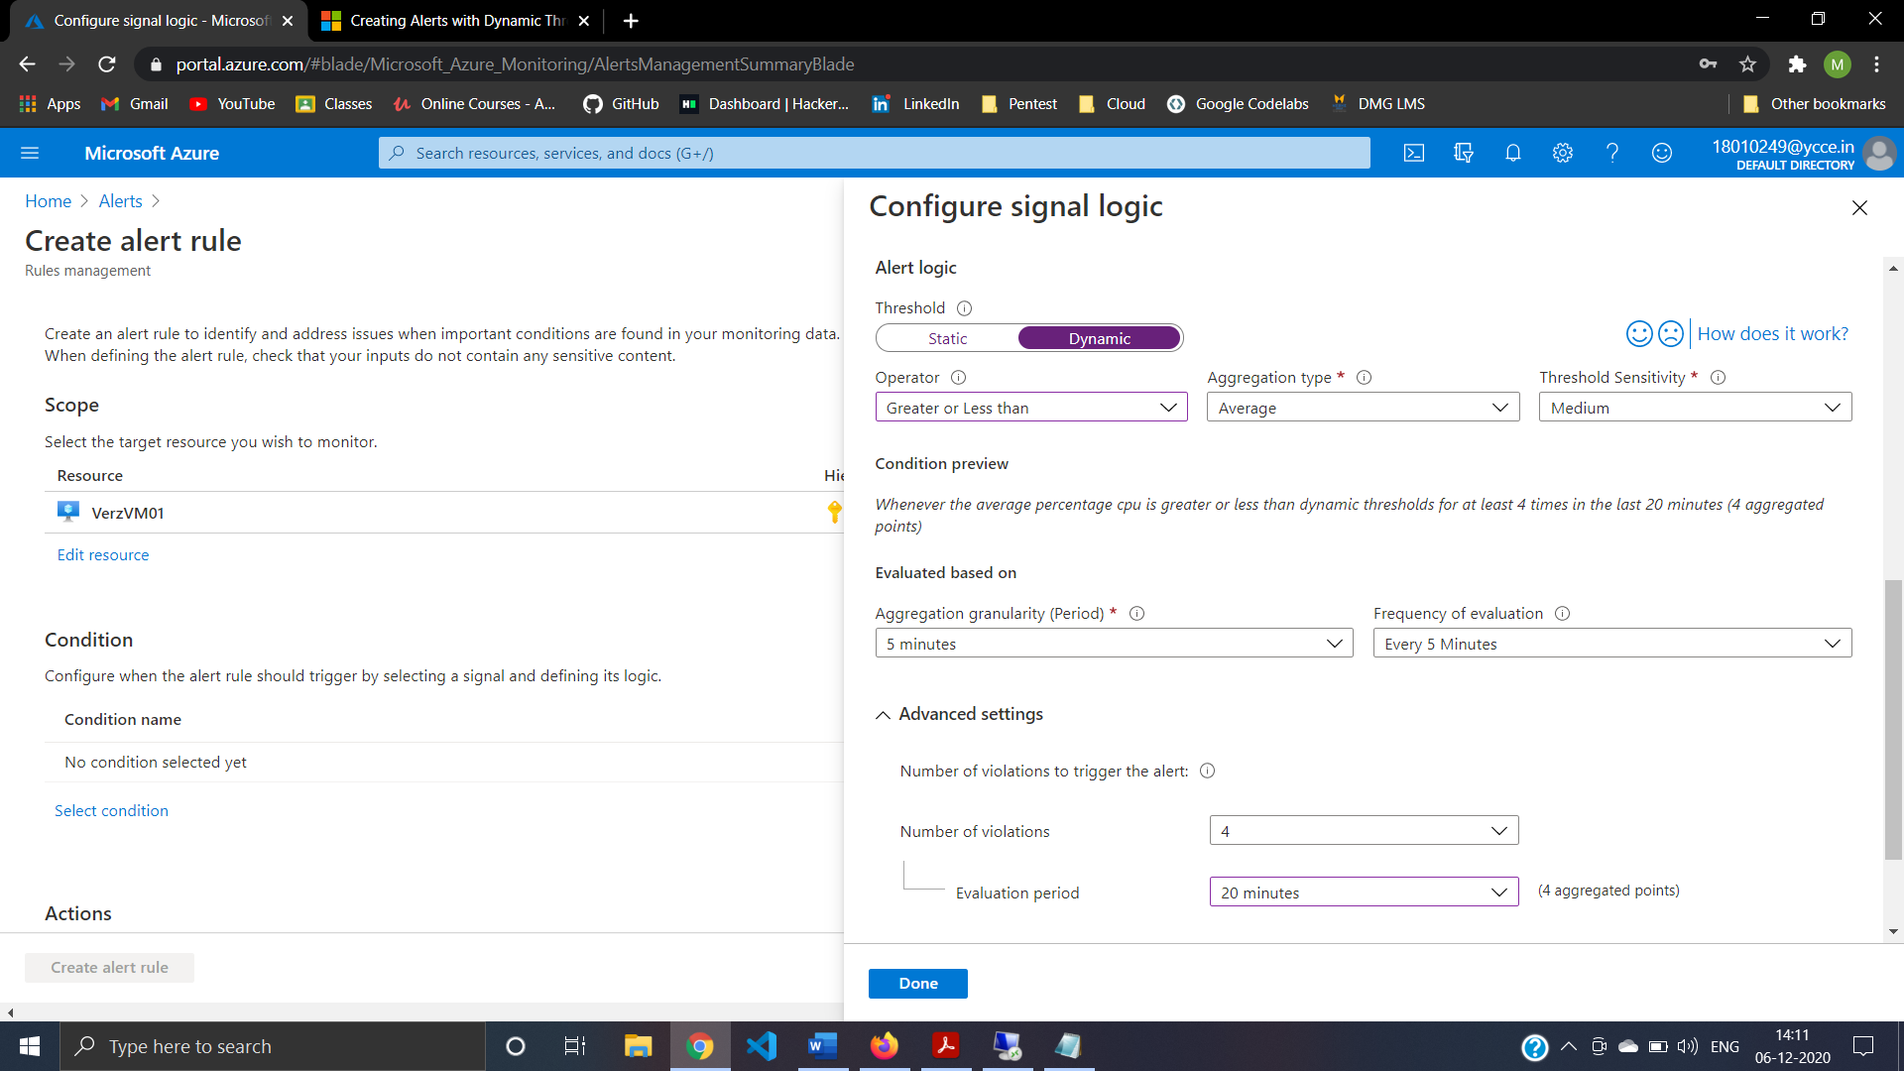

Step 42: Creating Alert group Verzactgrp 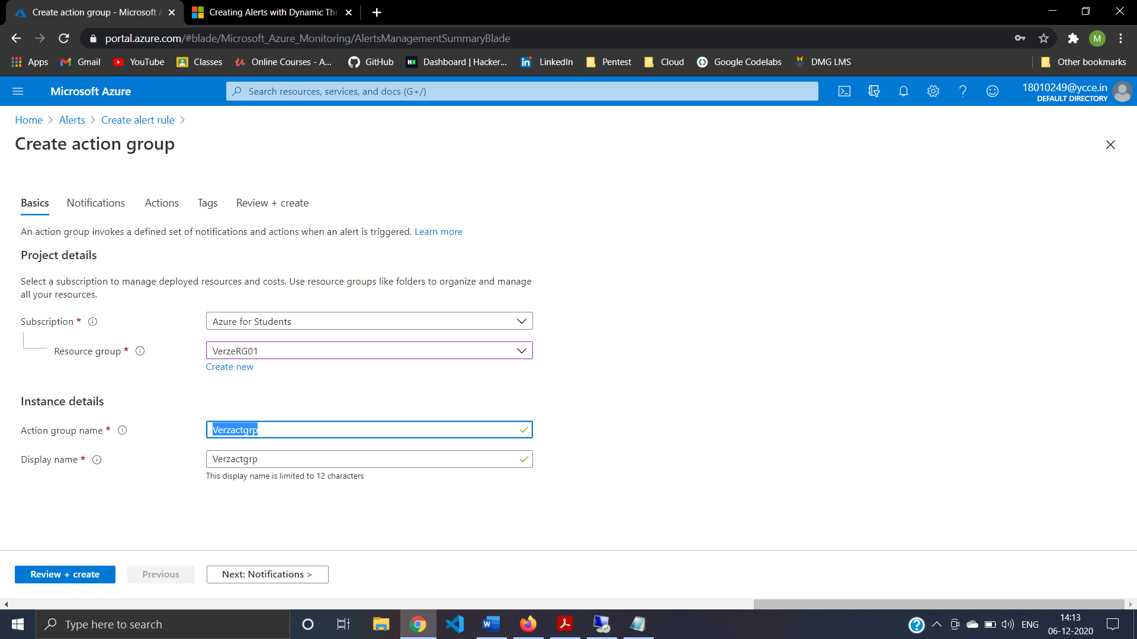

Step 43: Alert group Verzactgrp Notification 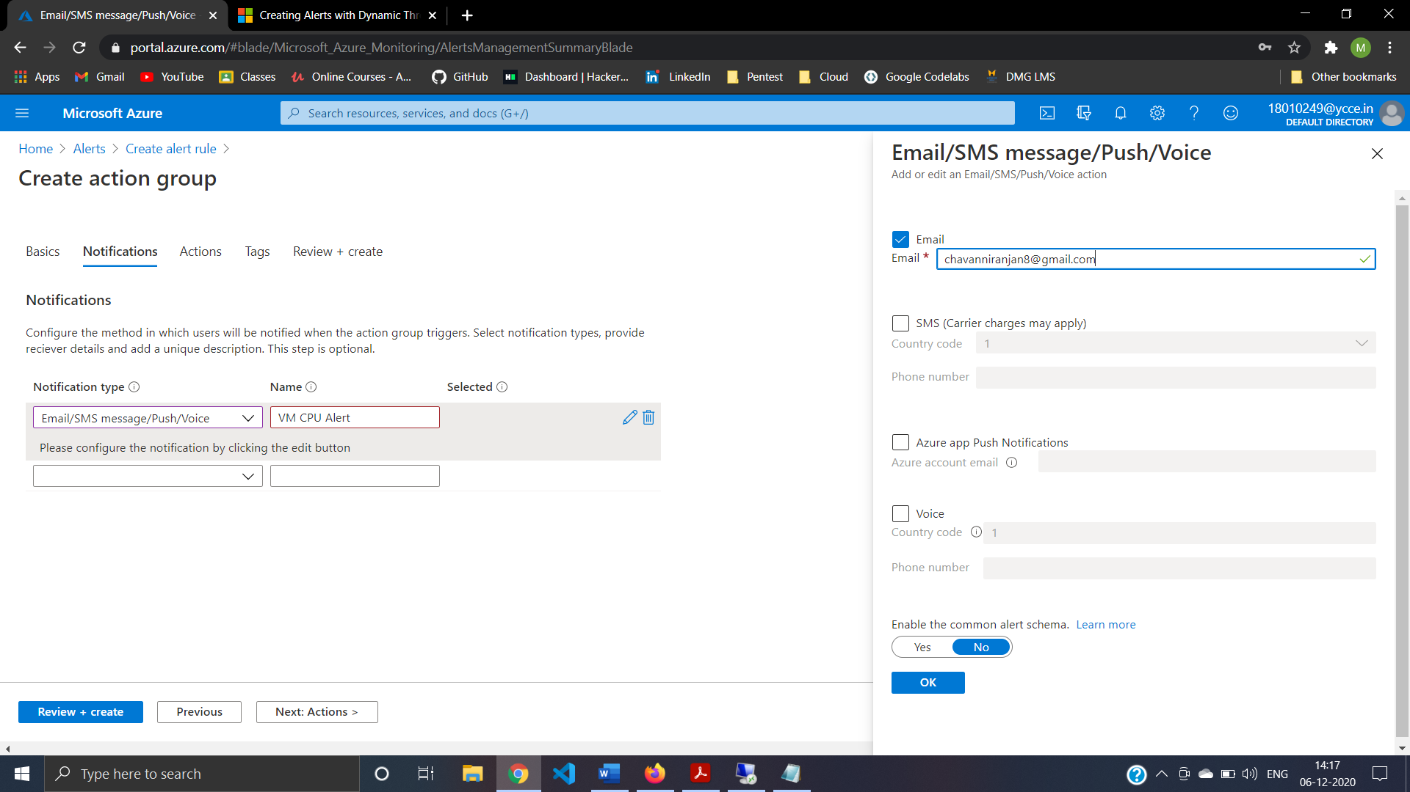

Step44: Review And Create Action Group 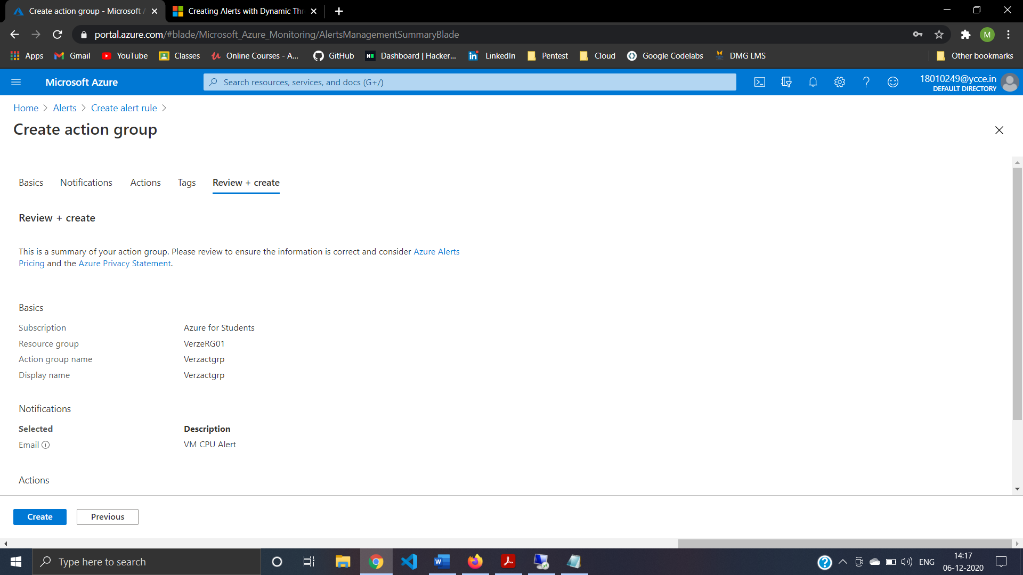

Step45: Create Alert Rule 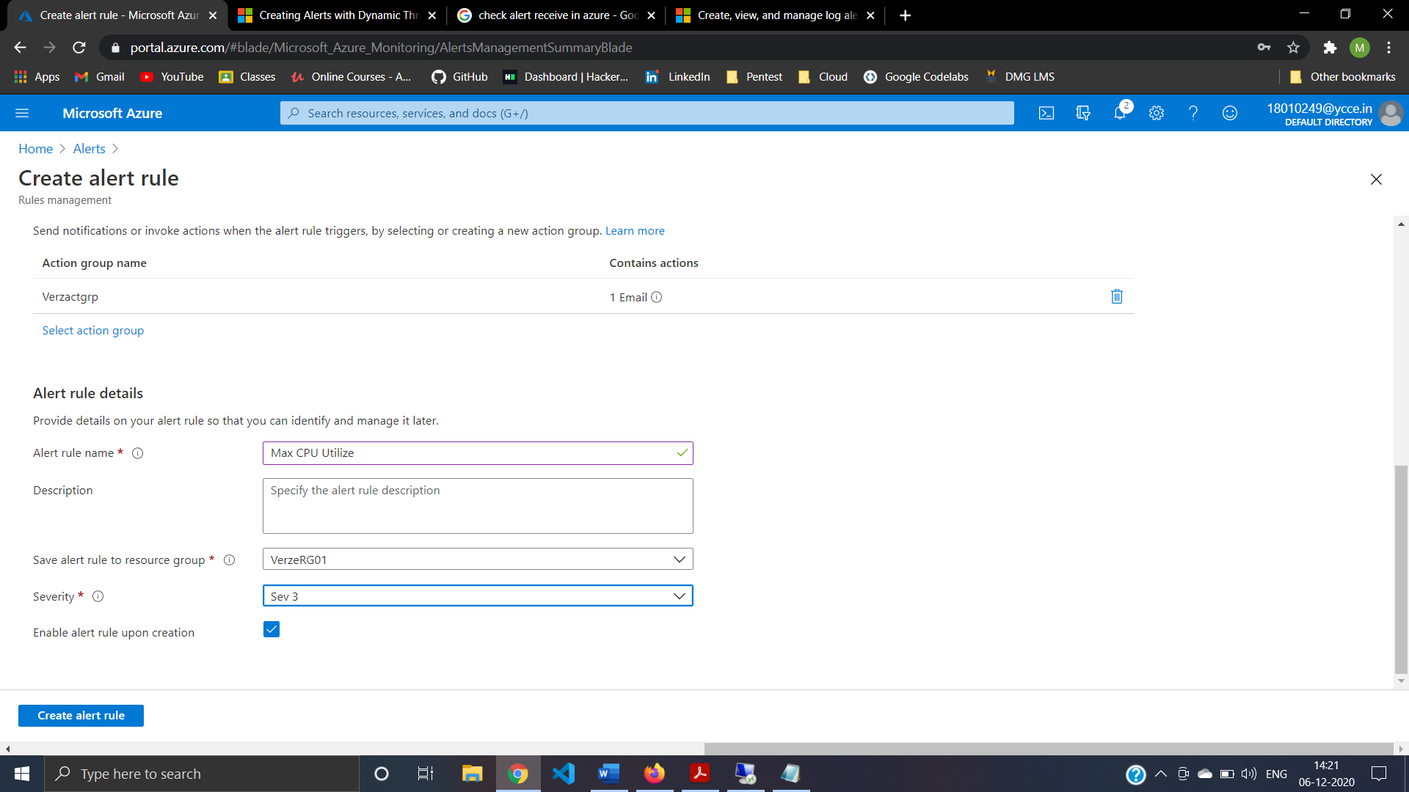

Step46: Successfully Check Receive Alert 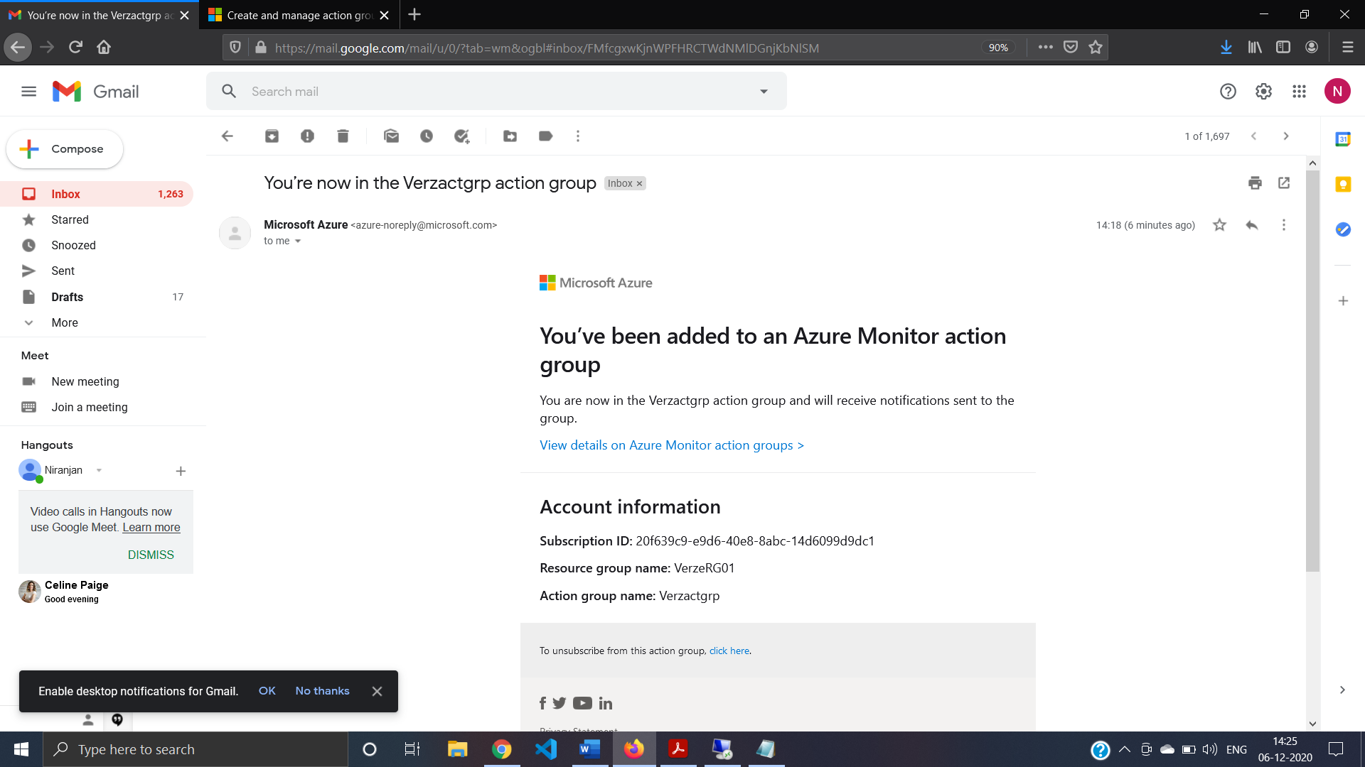

Step47:Create Recovery Service Vault (Vezvault01) 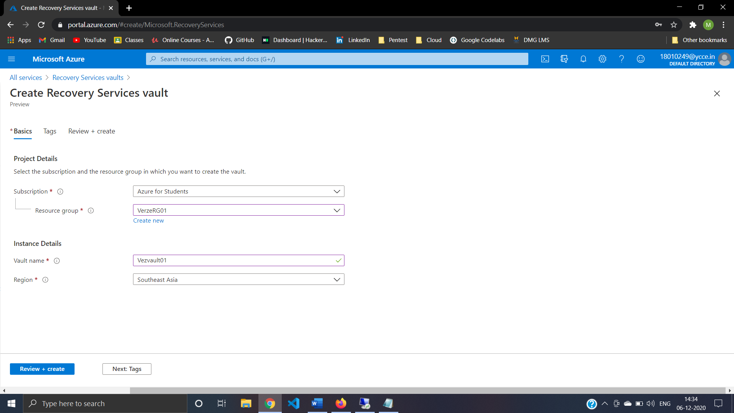

Step48:Create + Review Recovery Service Vault (Vezvault01) 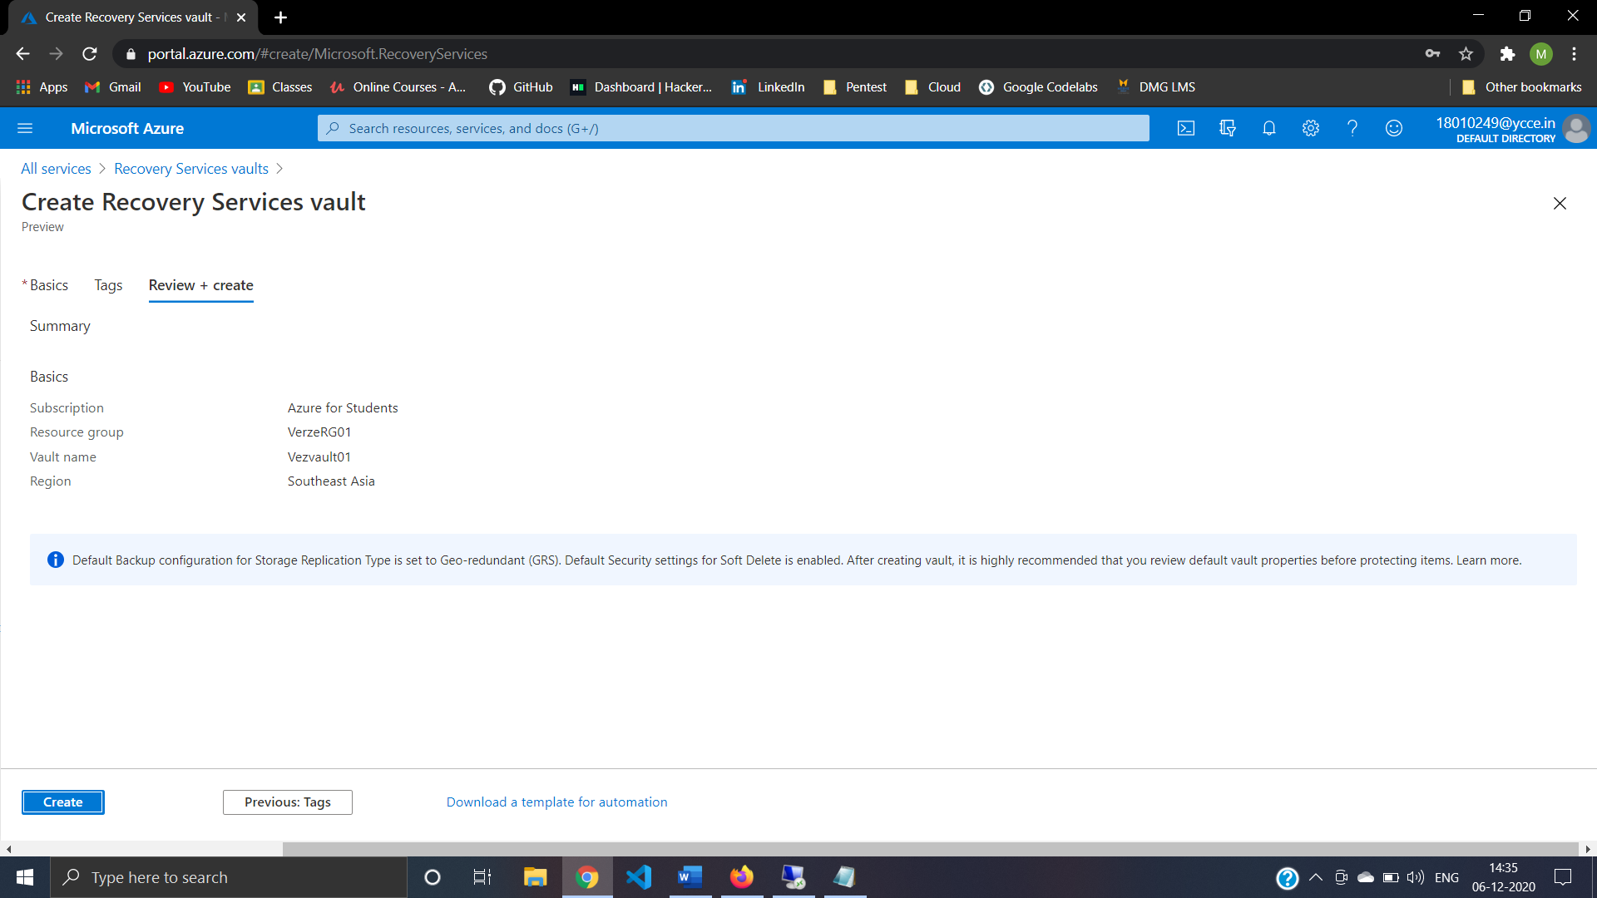

Step49: Select VerzVM01 For Backup

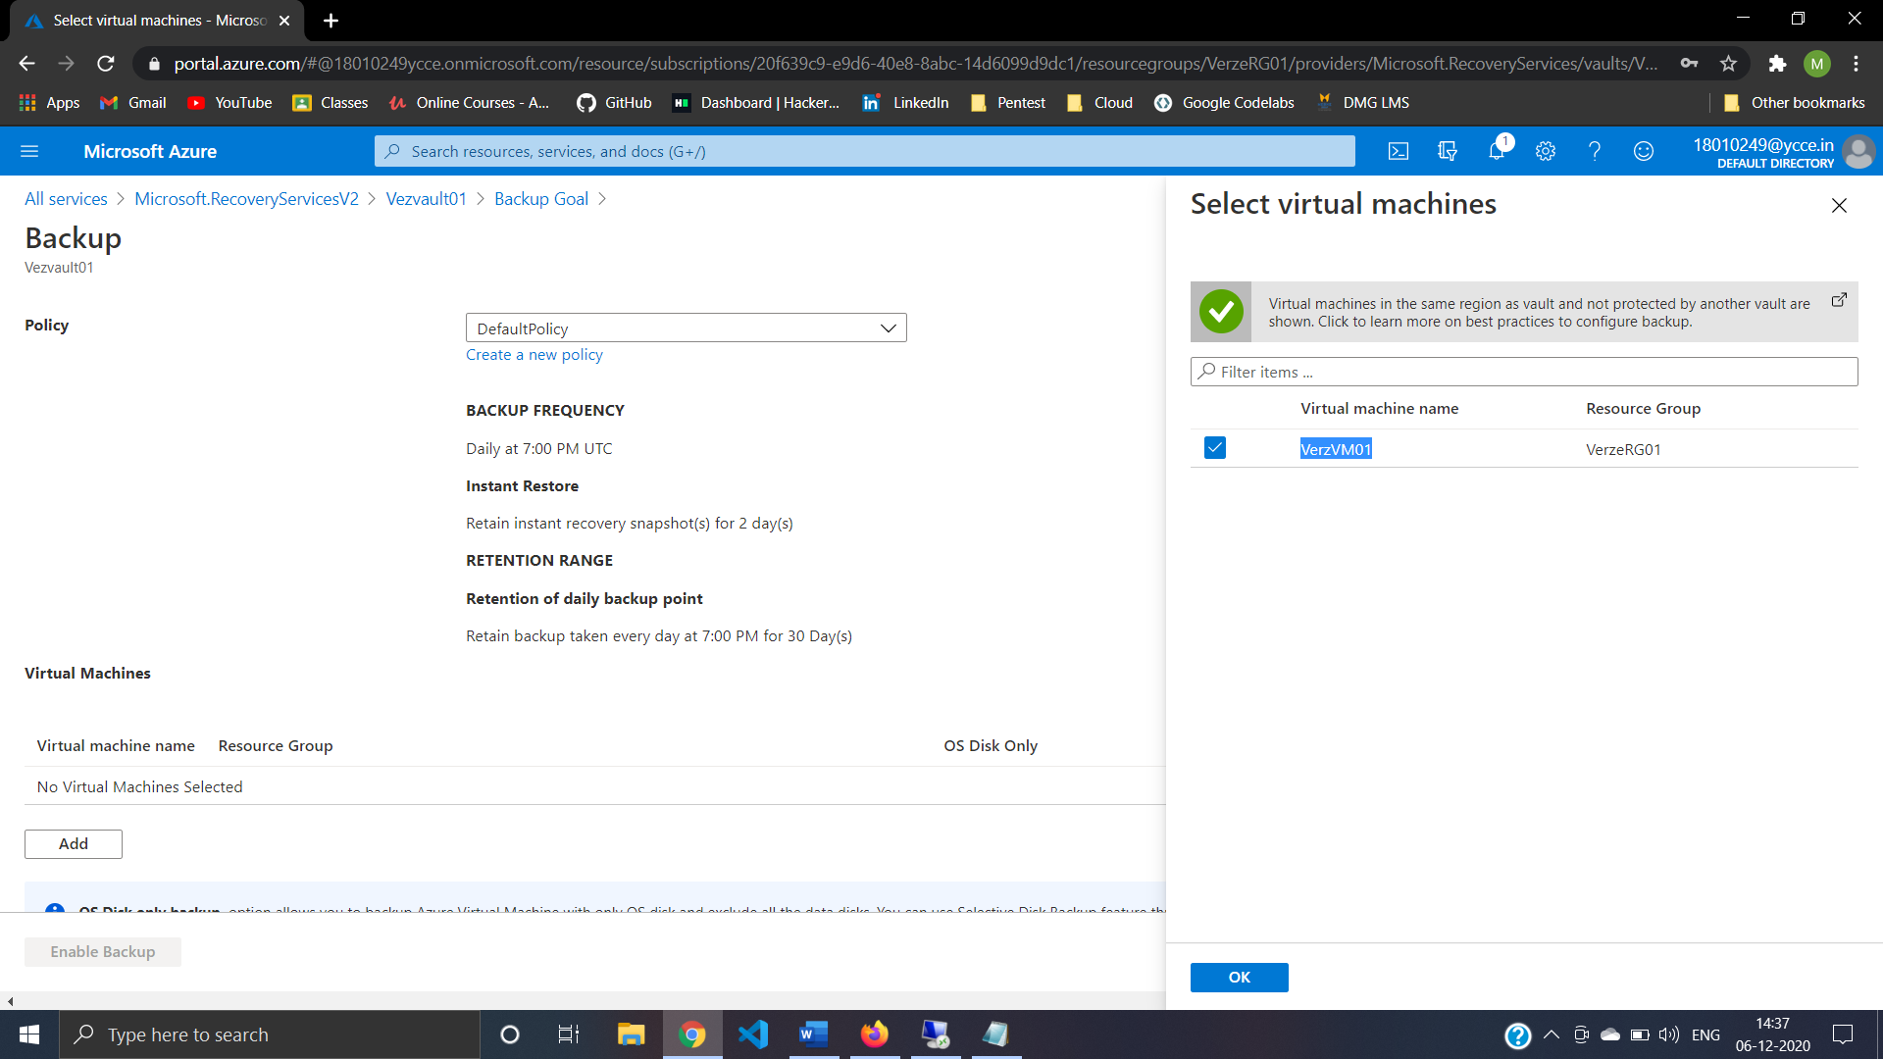

Step50: VerzVM01 Backup Working Successfully 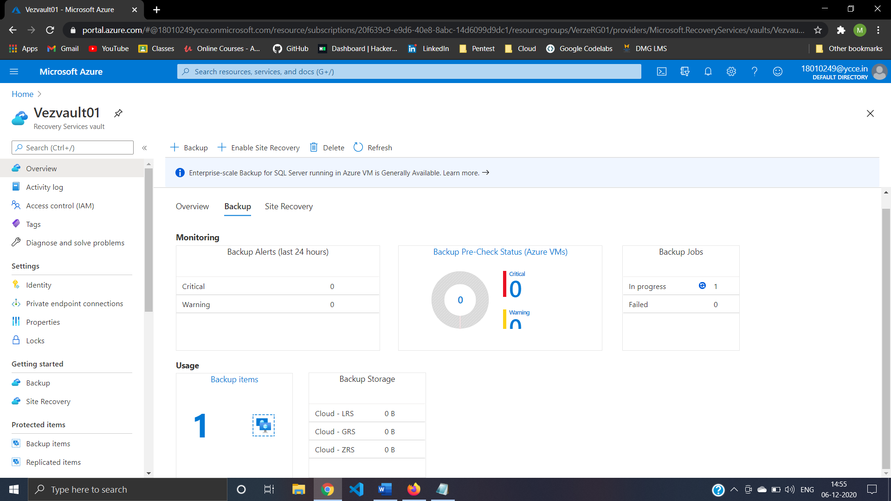

Step51:Wrapping up deleting Resources